CSS ISLAMIC STUDIES · T4QA
بِسۡمِ ٱللَّهِ ٱلرَّحۡمَٰنِ ٱلرَّحِيمِ
Topic IV — Human Rights, Human Dignity, Women and the Family
The Question Answers · Every past-paper question of Topic 4, 2015–2026, answered as a model
Twelve model answers — the family twice, women five times, human rights and dignity five times. Each begins with an answer map that states exactly what the question asks, builds its headings from the question's own words, and proves every heading from the Quran, the Sunnah and the scholars.
Edition of September 2026 · covers the papers of 2015–2026 · written for CSS 2027 and after
Contents
HOW TO BUILD THE CONTENTS
The Contents below is left empty on purpose. In Microsoft Word, right-click anywhere on the grey line below and choose Update Field → Update entire table → OK. The full table of contents with page numbers will appear.
On a Mac: right-click (or Control-click) the line → Update Field. If you edit the notes later, repeat this step to refresh the page numbers. You can also press Ctrl + A then F9 (Windows) to update every field in the document at once.

How to Use These Answers 6
What is in this document 6
How every answer is built 6
Answer 1 · The Last Sermon as the Basic Document of Human Rights (CSS 2020) 7
Decoding the question 7
The model answer 7
(1) Introduction 7
(2) The human rights declared in the Sermon 8
(3) Why it is the 'basic document' of human rights 10
(4) Why it 'awakened the conscience' of mankind 10
(5) Compared with the later charters 11
(6) An honest note 11
(7) Conclusion 11
Why this answer scores 12
Answer 2 · Short Notes: Human Rights in the Farewell Sermon; Social Justice in an Islamic Society (CSS 2023) 13
Decoding the question 13
The model answer 13
(i) Human rights in the light of the Sermon of the Farewell Pilgrimage 13
(ii) Social justice in an Islamic society 15
Why this answer scores 16
Answer 3 · Human Respect and Dignity Irrespective of Colour, Race and Creed (CSS 2020) 17
Decoding the question 17
The model answer 18
(1) Introduction 18
(2) The basis of human dignity 18
(3) Dignity irrespective of colour 19
(4) Dignity irrespective of race 19
(5) Dignity irrespective of creed 20
(6) Equality before the law — the practical test 21
(7) The modern relevance 21
(8) Conclusion 21
Why this answer scores 22
Answer 4 · How Islam Highlights Human Dignity and Greatness (CSS 2024) 23
Decoding the question 23
The model answer 24
(1) Introduction 24
(2) Greatness in his creation 24
(3) Greatness in his position and role 25
(4) Dignity of every human being — equality 26
(5) Dignity protected by law 27
(6) Dignity in every condition 28
(7) The scholars 29
(8) Dignity carries responsibility 29
(9) Conclusion 29
Why this answer scores 30
Answer 5 · Islam and the UDHR: A Comparative and Critical Analysis (CSS 2026) 31
Decoding the question 31
The model answer 31
(1) Introduction 31
(2) The similarities 32
(3) The differences 32
(4) Critical analysis of the UDHR and its practice 33
(5) Critical analysis of Muslim practice 34
(6) Verdict and conclusion 34
Why this answer scores 35
Answer 6 · Human Rights in Islamic Thought, with the Status of Women (CSS 2022) 36
Decoding the question 36
The model answer 37
(1) Introduction 37
(2) The concept of human rights in Islamic thought 37
(3) The status of women as human beings 38
(4) The rights of women 39
(5) The gap in practice — Pakistan 41
(6) Conclusion 41
Why this answer scores 41
Answer 7 · Islam Provides Better Rights to Men and Women than All Other Religions (CSS 2021) 42
Decoding the question 42
The model answer 43
(1) Introduction 43
(2) The basis — one humanity, no blame on woman 43
(3) Better rights for women — the comparison 43
(4) Better rights for men 45
(5) The balance of rights and duties 45
(6) An honest limit 46
(7) Conclusion 46
Why this answer scores 46
Answer 8 · The Rights of Daughters in Islam and Their Denial by Muslims Today (CSS 2023) 47
Decoding the question 47
The model answer 48
(1) Introduction 48
(2) The rights of daughters granted by Islam 48
(3) How these rights are denied by Muslims today 51
(4) Why — the causes 51
(5) The remedy 51
(6) Conclusion 52
Why this answer scores 52
Answer 9 · The Right of Inheritance Granted to Women by Islam (CSS 2017) 53
Decoding the question 53
The model answer 53
(1) Introduction 53
(2) The Quranic declaration of the right 54
(3) The shares of women in the Quran 54
(4) Why a son receives twice a daughter — the wisdom 55
(5) Cases where women receive equal or more 56
(6) Rules that protect her share 56
(7) The denial of women's inheritance today 57
(8) Conclusion 57
Why this answer scores 57
Answer 10 · The Rights of Women in Islam and the Current Wave of Feminism (CSS 2019) 58
Decoding the question 58
The model answer 58
(1) Introduction 58
(2) The feminist movement — its waves 59
(3) The rights of women in Islam 59
(4) Where Islam agrees with the demands of the movement 61
(5) Where Islam differs 61
(6) Custom, not Islam — the real oppressor 61
(7) Conclusion 62
Why this answer scores 62
Answer 11 · The Stability of Modern Society Depends on a Strong Family System (CSS 2015) 63
Decoding the question 63
The model answer 64
(1) Introduction 64
(2) The Islamic principles of the family 64
(3) How a strong family keeps society stable 65
(4) Islamic safeguards that keep the family strong 66
(5) What happens when the family fails — the modern evidence 66
(6) Conclusion 66
Why this answer scores 67
Answer 12 · The Challenges for the Institution of Family in the Present Era (CSS 2026) 68
Decoding the question 68
The model answer 69
(1) Introduction — the role of the family 69
(2) Social challenges 69
(3) Technological challenges 70
(4) Economic challenges 70
(5) Ideological challenges 71
(6) Injustice within families 71
(7) The Islamic remedies 72
(8) Conclusion 73
Why this answer scores 73

How to Use These Answers

What is in this document
# | Paper | Question (short) | Answer
1 | 2020 Q4 | The Last Sermon — the basic document for awakening mankind's conscience for human rights | Answer 1
2 | 2023 Q8 | Notes: human rights in the Farewell Sermon; social justice in an Islamic society | Answer 2
3 | 2020 Q7 | Human respect and dignity irrespective of colour, race and creed | Answer 3
4 | 2024 Q5 | How Islam highlights human dignity and greatness | Answer 4
5 | 2026 Q2 | Islam and the UDHR — comparative and critical analysis | Answer 5
6 | 2022 Q2 | Human rights in Islamic thought, specifying the status of women | Answer 6
7 | 2021 Q3 | Islam gives better rights to men and women than all other religions | Answer 7
8 | 2023 Q4 | Rights of daughters, and how Muslims deny them today | Answer 8
9 | 2017 Q3 | The right of inheritance granted to women | Answer 9
10 | 2019 Q4 | Rights of women in the context of the feminist movement | Answer 10
11 | 2015 Q8 | Stability of society depends on a strong family system | Answer 11
12 | 2026 Q8 | Challenges to the institution of the family in the present era | Answer 12

How every answer is built
1. The question, exactly as set.
2. The answer map — the centre states exactly what the question asks, limb by limb; every box is a heading, and every point is a complete idea (the verse or hadith and its point).
3. Decoding the question — the command words and what each limb demands.
4. The model answer — headings from the question's own words; evidence in the order Quran → Hadith → Companions → scholars; figures; the Pakistan angle; a conclusion with a verse or hadith.
5. Why this answer scores.
TRAP · USE THE ANSWERS AS MODELS, NOT SCRIPTS
Learn the structure and the evidence; build your headings from the words of the question you are given. A model answer is fuller than you can write in 33 minutes — choose the headings and evidence you can reproduce well.

Answer 1 · The Last Sermon as the Basic Document of Human Rights (CSS 2020)
THE QUESTION · CSS 2020 · Q4 · 20 marks
"The last Sermon of the Holy Prophet (PBUH) is the basic document for awakening of conscience of mankind for human rights". Discuss.

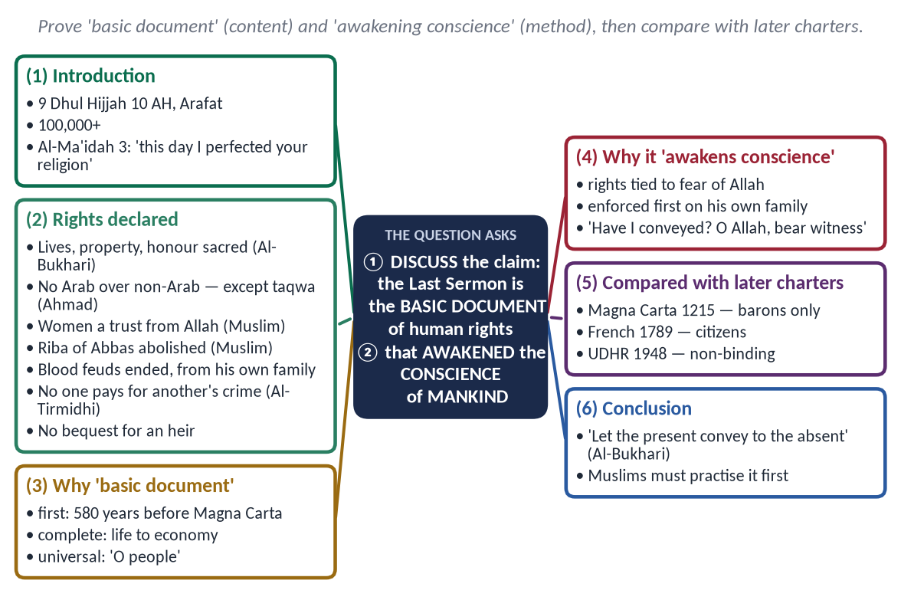
Figure 1 · The answer map: every branch is one numbered heading of the model answer below.

Decoding the question
- 'Discuss' = examine the claim with evidence; agree with reasons and note any limits.
- 'Basic document' = show its content — the rights it declared — and its priority in time.
- 'Awakening of conscience' = show how it moves hearts: rights tied to faith, set by example.
- 'Of mankind' = its universal address.

The model answer

(1) Introduction
On 9 Dhul Hijjah 10 AH (632), on the plain of Arafat, the Prophet ﷺ addressed more than a hundred thousand people in what became his Farewell Sermon — Khutbat Hajjat al-Wada' (خُطْبَةُ حَجَّةِ الْوَدَاع). On that day was revealed:
✦ QURAN
﴿… ٱلۡيَوۡمَ أَكۡمَلۡتُ لَكُمۡ دِينَكُمۡ وَأَتۡمَمۡتُ عَلَيۡكُمۡ نِعۡمَتِي وَرَضِيتُ لَكُمُ ٱلۡإِسۡلَٰمَ دِينٗاۚ …﴾
“This day I have perfected for you your religion, completed My favour upon you, and approved for you Islam as religion.” (Al-Ma'idah, Quran)
➜ 'This day I have perfected for you your religion' — the sermon stands at the completion of Islam.

It was his last public address and his summary of the rights of human beings. This answer shows that it is indeed the basic document of human rights and that it awakened the conscience of mankind.
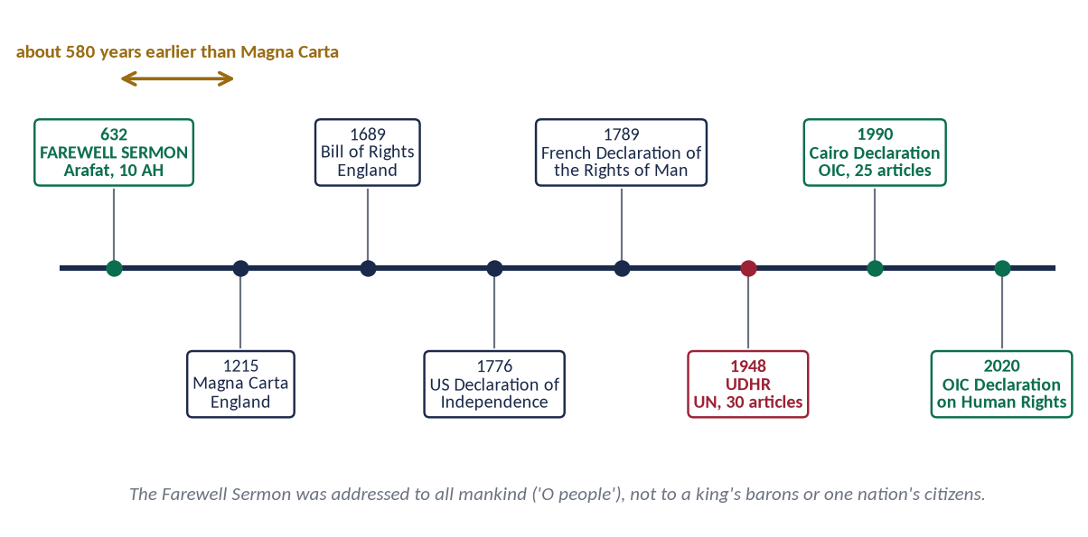
Figure 2 · The Farewell Sermon and the later charters of rights.

(2) The human rights declared in the Sermon

(i) Life, property and honour
✦ HADITH
فَإِنَّ دِمَاءَكُمْ وَأَمْوَالَكُمْ وَأَعْرَاضَكُمْ عَلَيْكُمْ حَرَامٌ، كَحُرْمَةِ يَوْمِكُمْ هَذَا
“Your lives, your property and your honour are sacred to one another, like the sanctity of this day.” (Al-Bukhari)
➜ The three basic rights of every later charter.

(ii) Equality of all human beings
✦ FROM THE SIRAH
أَلَا لَا فَضْلَ لِعَرَبِيٍّ عَلَى عَجَمِيٍّ، وَلَا لِعَجَمِيٍّ عَلَى عَرَبِيٍّ، وَلَا لِأَحْمَرَ عَلَى أَسْوَدَ، وَلَا أَسْوَدَ عَلَى أَحْمَرَ، إِلَّا بِالتَّقْوَى
“No Arab has superiority over a non-Arab, nor a non-Arab over an Arab, nor white over black, nor black over white — except by taqwa.” (Musnad Ahmad (the Farewell Sermon))
➜ The end of racism by declaration.

(iii) The rights of women
✦ HADITH
فَاتَّقُوا اللَّهَ فِي النِّسَاءِ، فَإِنَّكُمْ أَخَذْتُمُوهُنَّ بِأَمَانِ اللَّهِ
“Fear Allah concerning women, for you have taken them as a trust from Allah.” (Muslim)
➜ Women a trust; their maintenance and kind treatment a right.

(iv) Economic justice — riba abolished
✦ HADITH
وَرِبَا الْجَاهِلِيَّةِ مَوْضُوعٌ، وَأَوَّلُ رِبًا أَضَعُ رِبَانَا رِبَا عَبَّاسِ بْنِ عَبْدِ الْمُطَّلِبِ
“The riba of the Jahiliyyah is abolished; the first I abolish is our own — that of Abbas ibn Abd al-Muttalib.” (Muslim)
➜ The end of exploitation.

(v) The rule of law — blood feuds ended
The first blood-claim abolished was that of Ibn Rabi'ah ibn al-Harith of his own clan (Muslim) — private revenge replaced by law.

(vi) Personal responsibility
✦ HADITH
أَلَا لَا يَجْنِي جَانٍ إِلَّا عَلَى نَفْسِهِ
“No offender is responsible except for his own offence.” (Al-Tirmidhi and Ibn Majah)
➜ No collective punishment.

(vii) Inheritance, the weak and the Book
'Allah has given every rightful person his right — no bequest for an heir' (Abu Dawud); servants to be fed and clothed as their masters are (Ahmad); and 'I have left among you the Book of Allah' (Muslim) — law above persons.
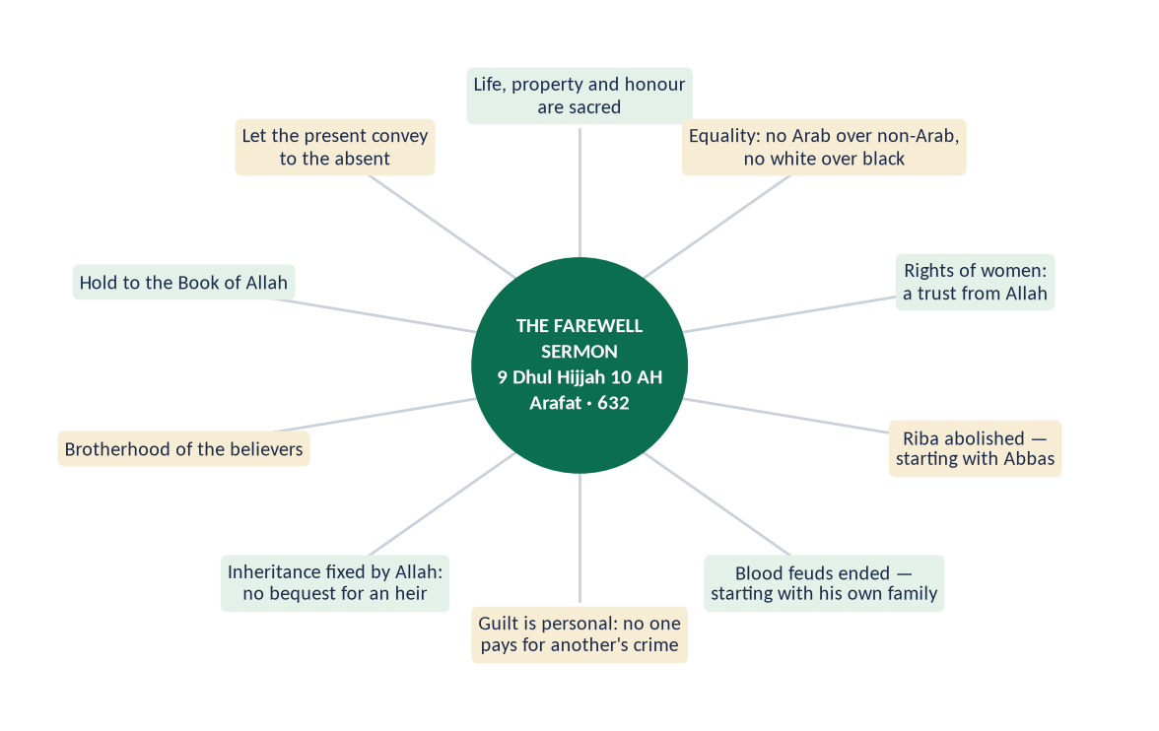
Figure 3 · The ten declarations of the Farewell Sermon.

(3) Why it is the 'basic document' of human rights
- (a) The first: about 580 years before Magna Carta (1215), 1,157 before the French Declaration (1789), 1,316 before the UDHR (1948).
- (b) The most complete: life, property, honour, equality, women, economy, justice, inheritance, the weak — in one short address.
- (c) Universal: 'O people' — addressed to mankind, not to barons or citizens of one state.
Right | Farewell Sermon (632) | UDHR (1948)
Life, security | 'Your lives are sacred' | Article 3
Property | 'Your property is sacred' | Article 17
Honour | 'Your honour is sacred' | Article 12
Equality | 'No Arab over a non-Arab…' | Articles 1, 2
Women | 'Fear Allah concerning women' | Article 16
Personal liability | 'No offender except for himself' | Article 11
Economic justice | Riba abolished | Articles 22–25

(4) Why it 'awakened the conscience' of mankind

(i) It tied rights to the fear of Allah
Every right came with 'fear Allah' — making the conscience the first guard of human rights. A law can be avoided; Allah cannot.

(ii) It was enforced first on the speaker's own family
Abbas's riba and Rabi'ah's blood were cancelled first — the conscience is moved when the leader applies the law to himself.

(iii) It made every listener a witness and a messenger
He asked, 'Have I not conveyed?' They said, 'Yes.' He raised his finger to the sky: 'O Allah, bear witness.'
✦ HADITH
لِيُبَلِّغِ الشَّاهِدُ الْغَائِبَ
“Let the one who is present convey to the one who is absent.” (Al-Bukhari)
➜ The sermon became the responsibility of every generation.

(5) Compared with the later charters
- Magna Carta (1215): rights of barons against the king.
- French Declaration (1789): rights of citizens of France, while colonies were ruled without rights.
- UDHR (1948): universal, but a non-binding declaration made by 58 states while most of the world was colonised.
- The Sermon: universal, moral and legal, and practised by the speaker.
✦ SCHOLARLY VIEW
Allama Muhammad Iqbal · The Reconstruction of Religious Thought in Islam
Iqbal saw in Islam a spiritual democracy — the equality, freedom and responsibility of all humans under one God — declared and lived by the Prophet ﷺ.
➜ The sermon is that spiritual democracy in words.

(6) An honest note
The Sermon's power is weakened when Muslims themselves deny its rights — to women, minorities and the poor. Its message is a standard that judges Muslim societies first.

(7) Conclusion
✦ QURAN
﴿يَـٰٓأَيُّهَا ٱلنَّاسُ إِنَّا خَلَقۡنَٰكُم مِّن ذَكَرٖ وَأُنثَىٰ وَجَعَلۡنَٰكُمۡ شُعُوبٗا وَقَبَآئِلَ لِتَعَارَفُوٓاْۚ إِنَّ أَكۡرَمَكُمۡ عِندَ ٱللَّهِ أَتۡقَىٰكُمۡۚ إِنَّ ٱللَّهَ عَلِيمٌ خَبِيرٞ﴾
“O mankind, indeed We have created you from male and female and made you peoples and tribes that you may know one another. Indeed, the most noble of you in the sight of Allah is the most righteous of you. Indeed, Allah is Knowing and Acquainted.” (Al-Hujurat, Quran)
➜ The most honoured of you is the most righteous.

The Farewell Sermon deserves to be called the basic document of human rights: it was first, complete and universal, and it awakened the conscience by joining every right to the fear of Allah and by enforcing it first on the speaker's own family. The world reached its words through centuries of struggle; the Muslim world must reach its practice.

Why this answer scores
- Both parts of the claim — 'basic document' and 'awakening of conscience' — have their own headings.
- Seven declarations are quoted with their Arabic lines, then matched with the UDHR.
- The comparison and the honest note show critical discussion.

Answer 2 · Short Notes: Human Rights in the Farewell Sermon; Social Justice in an Islamic Society (CSS 2023)
THE QUESTION · CSS 2023 · Q8 · 20 marks (10 + 10)
Write notes on the following: (i) Human rights in the light of the Sermon of the Farewell Pilgrimage; (ii) Social justice in an Islamic society.

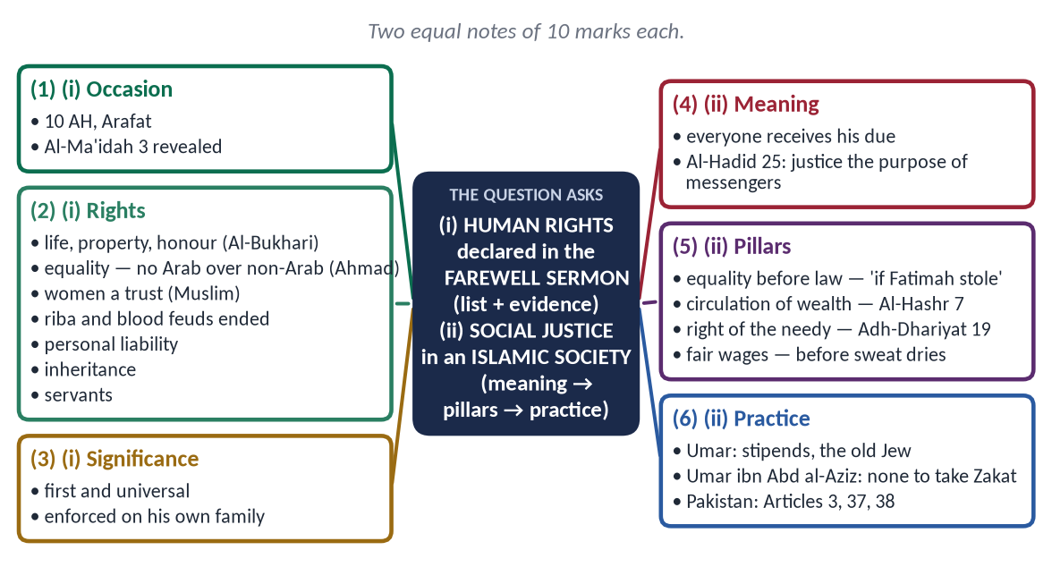
Figure 4 · The answer map: every branch is one numbered heading of the model answer below.

Decoding the question
- Two notes, 10 marks each — equal space.
- (i) List the rights with their words from the Sermon; a short significance.
- (ii) Define social justice, then its pillars and practice.

The model answer

(i) Human rights in the light of the Sermon of the Farewell Pilgrimage

Occasion
Delivered on 9 Dhul Hijjah 10 AH (632) at Arafat before more than a hundred thousand Companions, on the day Allah revealed: 'This day I have perfected your religion' (Al-Ma'idah 3).

The rights declared
- (a) Life, property and honour:
✦ HADITH
فَإِنَّ دِمَاءَكُمْ وَأَمْوَالَكُمْ وَأَعْرَاضَكُمْ عَلَيْكُمْ حَرَامٌ
“Your lives, property and honour are sacred to one another.” (Al-Bukhari)

- (b) Equality: 'No Arab over a non-Arab, no white over black — except by taqwa' (Ahmad).
- (c) Women:
✦ HADITH
فَاتَّقُوا اللَّهَ فِي النِّسَاءِ، فَإِنَّكُمْ أَخَذْتُمُوهُنَّ بِأَمَانِ اللَّهِ
“Fear Allah concerning women; you took them as a trust from Allah.” (Muslim)

- (d) Economic justice: riba abolished, first that of Abbas (Muslim).
- (e) Rule of law: blood feuds abolished, first that of Ibn Rabi'ah ibn al-Harith (Muslim).
- (f) Personal responsibility: 'No offender except for his own offence' (Al-Tirmidhi).
- (g) Inheritance: 'No bequest for an heir' (Abu Dawud).
- (h) Servants: fed and clothed as their masters.
- (i) Brotherhood and the Book: 'I have left among you the Book of Allah' (Muslim).
Figure 5 · The declarations of the Farewell Sermon.

Significance
The Sermon is the first universal charter of human rights — 580 years before Magna Carta — addressed to 'O people', and enforced first on the Prophet's ﷺ own family. It is the conscience behind every later declaration.

(ii) Social justice in an Islamic society

Meaning
Social justice — 'adl ijtima'i (عَدْلٌ اجْتِمَاعِي) — means that every member of society receives his due: equal treatment by law, fair opportunity, a share in wealth, and protection for the weak.
✦ QURAN
﴿لَقَدۡ أَرۡسَلۡنَا رُسُلَنَا بِٱلۡبَيِّنَٰتِ وَأَنزَلۡنَا مَعَهُمُ ٱلۡكِتَٰبَ وَٱلۡمِيزَانَ لِيَقُومَ ٱلنَّاسُ بِٱلۡقِسۡطِۖ …﴾
“We sent Our messengers with clear proofs and sent down with them the Book and the Balance, so that people may uphold justice.” (Al-Hadid, Quran)
➜ Allah sent His messengers with the Book and the Balance so that people may uphold justice — justice is the purpose of prophethood.

✦ QURAN
﴿إِنَّ ٱللَّهَ يَأۡمُرُ بِٱلۡعَدۡلِ وَٱلۡإِحۡسَٰنِ وَإِيتَآيِٕ ذِي ٱلۡقُرۡبَىٰ وَيَنۡهَىٰ عَنِ ٱلۡفَحۡشَآءِ وَٱلۡمُنكَرِ وَٱلۡبَغۡيِۚ يَعِظُكُمۡ لَعَلَّكُمۡ تَذَكَّرُونَ﴾
“Indeed, Allah orders justice and good conduct and giving to relatives and forbids immorality and bad conduct and oppression. He admonishes you that perhaps you will be reminded.” (An-Nahl, Quran)
➜ Allah commands justice, excellence and giving to relatives.

The pillars of social justice
- (a) Equality before law:
✦ HADITH
وَايْمُ اللَّهِ لَوْ أَنَّ فَاطِمَةَ بِنْتَ مُحَمَّدٍ سَرَقَتْ لَقَطَعْتُ يَدَهَا
“By Allah, if Fatimah daughter of Muhammad stole, I would cut her hand.” (Al-Bukhari and Muslim)
➜ No privilege for the powerful.

- (b) Circulation of wealth:
✦ QURAN
﴿… كَيۡ لَا يَكُونَ دُولَةَۢ بَيۡنَ ٱلۡأَغۡنِيَآءِ مِنكُمۡۚ …﴾
“… so that it does not circulate only among the rich among you.” (Al-Hashr, Quran)
➜ So that wealth does not circulate only among the rich — through Zakat, inheritance, and the ban on riba and hoarding.

- (c) Right of the needy: 'In their wealth is a right for the one who asks and the deprived' (Adh-Dhariyat 19).
- (d) Dignity of labour: 'Give the worker his wage before his sweat dries' (Ibn Majah).
- (e) Equal opportunity: Bilal, Salman and Usamah rose by merit, not birth.
- (f) Accountable rulers: the ruler is a servant — 'each of you is a shepherd' (Al-Bukhari).

Social justice in practice
- Hazrat Umar (RA) fixed stipends for every citizen, even newborns, and for a poor old Jew from the treasury (Abu Yusuf, Kitab al-Kharaj).
- Under Umar ibn Abd al-Aziz (717–720), Zakat collectors could find no one poor enough to take it.

Pakistan
The Constitution promises the elimination of exploitation (Article 3), social justice (Article 37) and the well-being of the people (Article 38); with about 40 percent below the poverty line, implementation — not principle — is the gap.

Why this answer scores
- Equal space for two 10-mark notes.
- Note (i) gives the Sermon's own words for each right.
- Note (ii) moves from meaning → pillars → practice → Pakistan.

Answer 3 · Human Respect and Dignity Irrespective of Colour, Race and Creed (CSS 2020)
THE QUESTION · CSS 2020 · Q7 · 20 marks
"Islam teaches the lesson of human respect and dignity irrespective of colour, race and creed". Discuss.

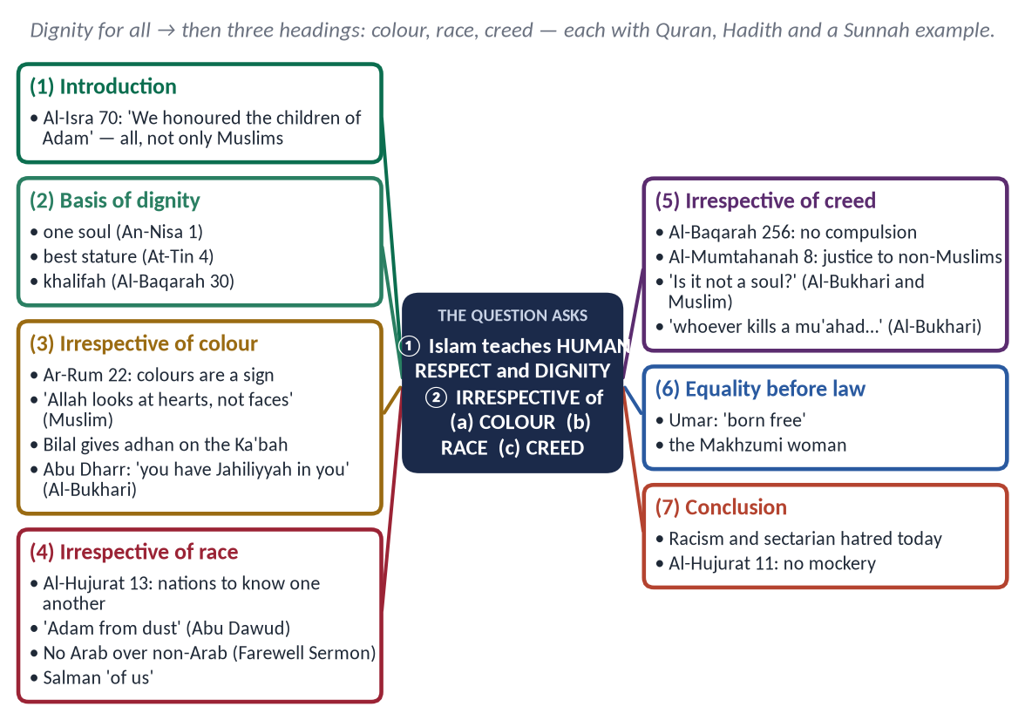
Figure 6 · The answer map: every branch is one numbered heading of the model answer below.

Decoding the question
- 'Human respect and dignity' = the Islamic basis of dignity for every human being.
- 'Irrespective of colour, race and creed' = three separate headings — the creed limb is the one most candidates forget.
- 'Discuss' = evidence plus practice, and the modern relevance.

The model answer

(1) Introduction
✦ QURAN
﴿وَلَقَدۡ كَرَّمۡنَا بَنِيٓ ءَادَمَ وَحَمَلۡنَٰهُمۡ فِي ٱلۡبَرِّ وَٱلۡبَحۡرِ وَرَزَقۡنَٰهُم مِّنَ ٱلطَّيِّبَٰتِ وَفَضَّلۡنَٰهُمۡ عَلَىٰ كَثِيرٖ مِّمَّنۡ خَلَقۡنَا تَفۡضِيلٗا﴾
“And We have certainly honored the children of Adam and carried them on the land and sea and provided for them of the good things and preferred them over much of what We have created, with [definite] preference.” (Al-Isra, Quran)
➜ 'We have honoured the children of Adam' — not the Arabs, not the believers, but all the children of Adam.

In the seventh century, human worth was measured by tribe, colour, wealth and religion. Islam declared that dignity is given by Allah to every human being and cannot be taken away by colour, race or creed.

(2) The basis of human dignity
✦ QURAN
﴿يَـٰٓأَيُّهَا ٱلنَّاسُ ٱتَّقُواْ رَبَّكُمُ ٱلَّذِي خَلَقَكُم مِّن نَّفۡسٖ وَٰحِدَةٖ وَخَلَقَ مِنۡهَا زَوۡجَهَا وَبَثَّ مِنۡهُمَا رِجَالٗا كَثِيرٗا وَنِسَآءٗۚ …﴾
“O mankind, fear your Lord, who created you from one soul, created from it its mate, and spread from both of them many men and women.” (An-Nisa, Quran)
➜ All mankind was created from one soul — one family.

✦ QURAN
﴿لَقَدۡ خَلَقۡنَا ٱلۡإِنسَٰنَ فِيٓ أَحۡسَنِ تَقۡوِيمٖ﴾
“We have certainly created man in the best of stature.” (At-Tin, Quran)
➜ 'We created man in the best of stature.'

✦ QURAN
﴿… إِنِّي جَاعِلٞ فِي ٱلۡأَرۡضِ خَلِيفَةٗۖ …﴾
“Indeed, I will make upon the earth a vicegerent (khalifah).” (Al-Baqarah, Quran)
➜ Man is Allah's vicegerent (khalifah) on earth.

(3) Dignity irrespective of colour
✦ QURAN
﴿وَمِنۡ ءَايَٰتِهِۦ خَلۡقُ ٱلسَّمَٰوَٰتِ وَٱلۡأَرۡضِ وَٱخۡتِلَٰفُ أَلۡسِنَتِكُمۡ وَأَلۡوَٰنِكُمۡۚ إِنَّ فِي ذَٰلِكَ لَأٓيَٰتٖ لِّلۡعَٰلِمِينَ﴾
“And of His signs is the creation of the heavens and the earth and the diversity of your languages and your colors. Indeed in that are signs for those of knowledge.” (Ar-Rum, Quran)
➜ The diversity of your languages and colours is a sign of Allah — a mark of His art, not of rank.

✦ HADITH
إِنَّ اللَّهَ لَا يَنْظُرُ إِلَى صُوَرِكُمْ وَأَمْوَالِكُمْ، وَلَكِنْ يَنْظُرُ إِلَى قُلُوبِكُمْ وَأَعْمَالِكُمْ
“Allah does not look at your appearance or your wealth, but at your hearts and your deeds.” (Muslim)

- Bilal (RA), a black former slave, was chosen to give the adhan from the roof of the Ka'bah on the day Makkah was conquered, while the Quraysh chiefs watched.
- When Abu Dharr (RA) taunted a man about his black mother, the Prophet ﷺ said:
✦ HADITH
إِنَّكَ امْرُؤٌ فِيكَ جَاهِلِيَّةٌ
“You are a man in whom there is still Jahiliyyah.” (Al-Bukhari)
➜ Colour prejudice is pre-Islamic ignorance.

(4) Dignity irrespective of race
✦ QURAN
﴿يَـٰٓأَيُّهَا ٱلنَّاسُ إِنَّا خَلَقۡنَٰكُم مِّن ذَكَرٖ وَأُنثَىٰ وَجَعَلۡنَٰكُمۡ شُعُوبٗا وَقَبَآئِلَ لِتَعَارَفُوٓاْۚ إِنَّ أَكۡرَمَكُمۡ عِندَ ٱللَّهِ أَتۡقَىٰكُمۡۚ إِنَّ ٱللَّهَ عَلِيمٌ خَبِيرٞ﴾
“O mankind, indeed We have created you from male and female and made you peoples and tribes that you may know one another. Indeed, the most noble of you in the sight of Allah is the most righteous of you. Indeed, Allah is Knowing and Acquainted.” (Al-Hujurat, Quran)
➜ Nations and tribes were made to know one another; the most honoured is the most righteous.

✦ HADITH
النَّاسُ بَنُو آدَمَ، وَآدَمُ مِنْ تُرَابٍ
“People are the children of Adam, and Adam was from dust.” (Abu Dawud and Al-Tirmidhi)

✦ FROM THE SIRAH
لَا فَضْلَ لِعَرَبِيٍّ عَلَى عَجَمِيٍّ، وَلَا لِعَجَمِيٍّ عَلَى عَرَبِيٍّ ... إِلَّا بِالتَّقْوَى
“No Arab has superiority over a non-Arab, nor a non-Arab over an Arab … except by taqwa.” (Musnad Ahmad (the Farewell Sermon))

- Salman (RA) the Persian: 'Salman is one of us, the people of the house' (Al-Hakim).
- Suhayb (RA) the Roman and Bilal (RA) the Abyssinian stood with the Quraysh as equals.
- Usamah ibn Zayd (RA), son of a freed slave, commanded an army that included senior Companions.

(5) Dignity irrespective of creed
✦ QURAN
﴿لَآ إِكۡرَاهَ فِي ٱلدِّينِۖ قَد تَّبَيَّنَ ٱلرُّشۡدُ مِنَ ٱلۡغَيِّۚ …﴾
“There is no compulsion in religion; the right course has become clear from the wrong.” (Al-Baqarah, Quran)
➜ No compulsion in religion.

✦ QURAN
﴿لَّا يَنۡهَىٰكُمُ ٱللَّهُ عَنِ ٱلَّذِينَ لَمۡ يُقَٰتِلُوكُمۡ فِي ٱلدِّينِ وَلَمۡ يُخۡرِجُوكُم مِّن دِيَٰرِكُمۡ أَن تَبَرُّوهُمۡ وَتُقۡسِطُوٓاْ إِلَيۡهِمۡۚ إِنَّ ٱللَّهَ يُحِبُّ ٱلۡمُقۡسِطِينَ﴾
“Allah does not forbid you from those who do not fight you because of religion and do not expel you from your homes - from being righteous toward them and acting justly toward them. Indeed, Allah loves those who act justly.” (Al-Mumtahanah, Quran)
➜ Allah does not forbid kindness and justice to those who do not fight you.

✦ HADITH
أَلَيْسَتْ نَفْسًا
“Is it not a soul?” (Al-Bukhari and Muslim)
➜ He stood for a Jewish funeral.

✦ HADITH
مَنْ قَتَلَ مُعَاهَدًا لَمْ يَرِحْ رَائِحَةَ الْجَنَّةِ
“Whoever kills a non-Muslim under covenant will not smell the fragrance of Paradise.” (Al-Bukhari)

- The Christians of Najran prayed in the Mosque of Madinah; their churches were protected by treaty.
- Umar (RA) gave a poor old Jew a stipend from the treasury.
- Ali (RA), as Caliph, lost a case over his shield to a non-Muslim before Qadi Shurayh.

(6) Equality before the law — the practical test
When the governor's son struck an Egyptian commoner, Umar (RA) had the Egyptian strike back and said:
✦ SCHOLARLY VIEW
Hazrat Umar Farooq (RA) · Second Rightly-Guided Caliph, to his governor of Egypt
“Since when have you enslaved people when their mothers bore them free?”
➜ Dignity before the law, regardless of rank.

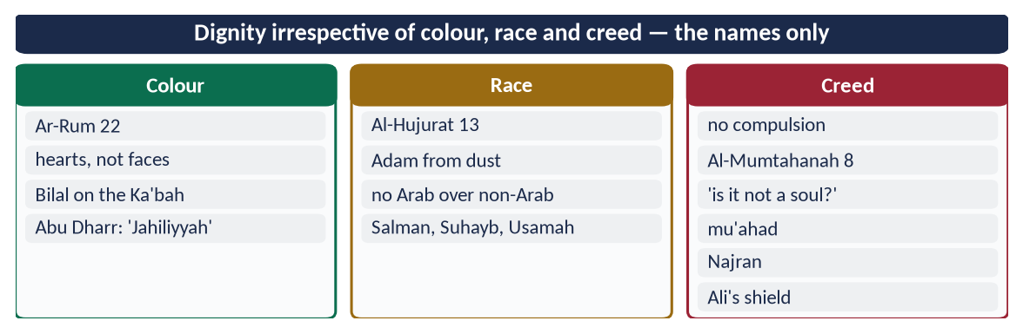
Figure 7 · At a glance — dignity irrespective of colour, race and creed — the names only. The detail is in the sections above.

(7) The modern relevance
Racism in the West, caste in South Asia, ethnic and sectarian hatred in Muslim lands, and Islamophobia all deny this lesson. Pakistan's Articles 25, 20 and 36 reflect it; our society must practise it — in how we treat the poor, other ethnic groups, other sects and minorities.

(8) Conclusion
✦ QURAN
﴿… لَا يَسۡخَرۡ قَوۡمٞ مِّن قَوۡمٍ عَسَىٰٓ أَن يَكُونُواْ خَيۡرٗا مِّنۡهُمۡ وَلَا نِسَآءٞ مِّن نِّسَآءٍ عَسَىٰٓ أَن يَكُنَّ خَيۡرٗا مِّنۡهُنَّۖ …﴾
“Let not a people ridicule another people — perhaps they are better than them; nor let women ridicule other women — perhaps they are better than them.” (Al-Hujurat, Quran)
➜ Let no people mock another people — perhaps they are better than them.

Islam does not merely tolerate difference; it honours the human being as such. Colour is a sign of Allah's art, race a means of recognition, and creed a matter of free choice — none of them a reason to deny anyone respect. That is the lesson of the Quran, the Sunnah and the Rightly-Guided Caliphs, and the world still needs it.

Why this answer scores
- Three headings — colour, race, creed — exactly as the question lists them; creed is not forgotten.
- Each has Quran → Hadith → Sunnah example.
- The modern relevance section turns 'teaches the lesson' into a lesson for today.

Answer 4 · How Islam Highlights Human Dignity and Greatness (CSS 2024)
THE QUESTION · CSS 2024 · Q5 · 20 marks
How does Islam highlight human dignity and greatness? Discuss.

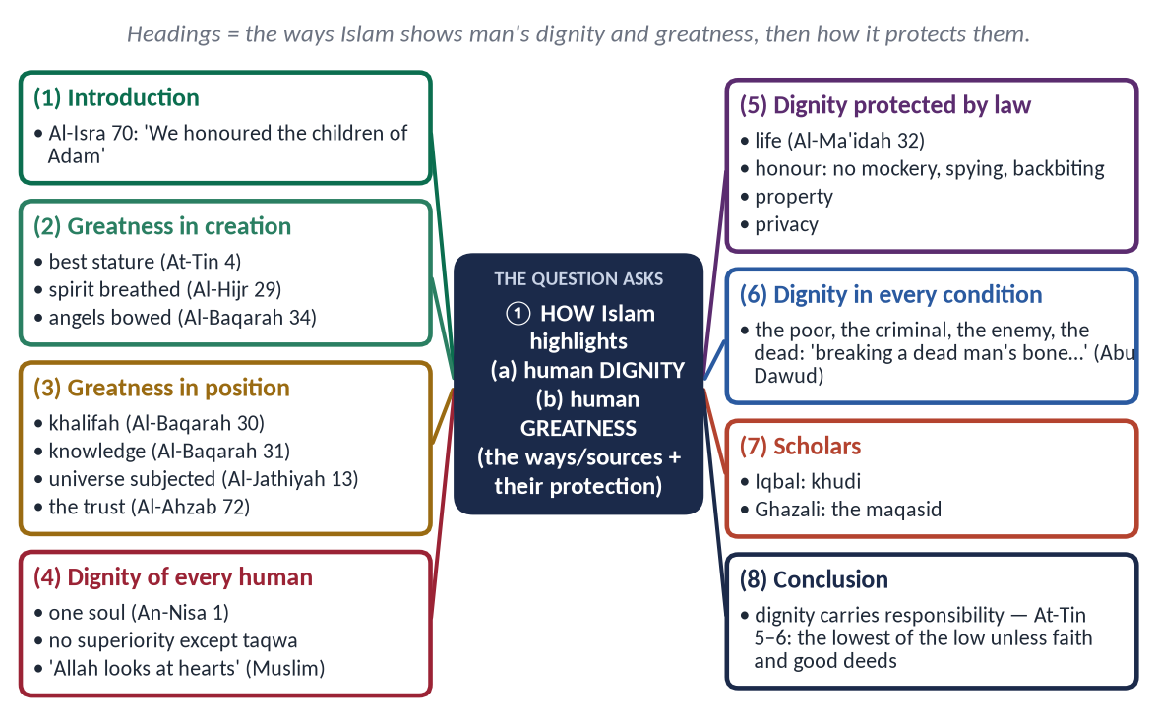
Figure 8 · The answer map: every branch is one numbered heading of the model answer below.

Decoding the question
- 'How' = the ways and sources through which Islam shows human dignity — not only a statement that it does.
- 'Dignity' (karamah, كَرَامَة) = honour due to every human; 'greatness' = man's high position and potential.
- 'Discuss' = add the protection of dignity in law and practice, and the responsibility that comes with it.

The model answer

(1) Introduction
✦ QURAN
﴿وَلَقَدۡ كَرَّمۡنَا بَنِيٓ ءَادَمَ وَحَمَلۡنَٰهُمۡ فِي ٱلۡبَرِّ وَٱلۡبَحۡرِ وَرَزَقۡنَٰهُم مِّنَ ٱلطَّيِّبَٰتِ وَفَضَّلۡنَٰهُمۡ عَلَىٰ كَثِيرٖ مِّمَّنۡ خَلَقۡنَا تَفۡضِيلٗا﴾
“And We have certainly honored the children of Adam and carried them on the land and sea and provided for them of the good things and preferred them over much of what We have created, with [definite] preference.” (Al-Isra, Quran)
➜ 'We have honoured the children of Adam', carried them on land and sea, provided them with good things and preferred them over much of creation.

Philosophies have described man as a talking animal, a machine, or a product of chance. Islam describes him as the honoured vicegerent of Allah, created with purpose and entrusted with the earth. It highlights his dignity and greatness in his creation, his position, his equality and in the laws that protect him.

(2) Greatness in his creation

(i) The best form
✦ QURAN
﴿لَقَدۡ خَلَقۡنَا ٱلۡإِنسَٰنَ فِيٓ أَحۡسَنِ تَقۡوِيمٖ﴾
“We have certainly created man in the best of stature.” (At-Tin, Quran)
➜ 'We created man in the best of stature.'

(ii) The spirit of Allah
✦ QURAN
﴿فَإِذَا سَوَّيۡتُهُۥ وَنَفَخۡتُ فِيهِ مِن رُّوحِي فَقَعُواْ لَهُۥ سَٰجِدِينَ﴾
“And when I have proportioned him and breathed into him of My [created] soul, then fall down to him in prostration.” (Al-Hijr, Quran)
➜ 'When I have proportioned him and breathed into him of My spirit, fall down to him in prostration.'

(iii) The angels bowed to him
✦ QURAN
﴿وَإِذۡ قُلۡنَا لِلۡمَلَـٰٓئِكَةِ ٱسۡجُدُواْ لِأٓدَمَ فَسَجَدُوٓاْ إِلَّآ إِبۡلِيسَ أَبَىٰ وَٱسۡتَكۡبَرَ وَكَانَ مِنَ ٱلۡكَٰفِرِينَ﴾
“And [mention] when We said to the angels, "Prostrate before Adam"; so they prostrated, except for Iblees. He refused and was arrogant and became of the disbelievers.” (Al-Baqarah, Quran)
➜ The angels were commanded to prostrate to Adam — honour above the angels.

(3) Greatness in his position and role

(i) Vicegerent on earth
✦ QURAN
﴿… إِنِّي جَاعِلٞ فِي ٱلۡأَرۡضِ خَلِيفَةٗۖ …﴾
“Indeed, I will make upon the earth a vicegerent (khalifah).” (Al-Baqarah, Quran)
➜ 'I will make upon the earth a vicegerent (khalifah).'

(ii) Knowledge — the basis of his rank
✦ QURAN
﴿وَعَلَّمَ ءَادَمَ ٱلۡأَسۡمَآءَ كُلَّهَا ثُمَّ عَرَضَهُمۡ عَلَى ٱلۡمَلَـٰٓئِكَةِ فَقَالَ أَنۢبِـُٔونِي بِأَسۡمَآءِ هَـٰٓؤُلَآءِ إِن كُنتُمۡ صَٰدِقِينَ﴾
“And He taught Adam the names - all of them. Then He showed them to the angels and said, "Inform Me of the names of these, if you are truthful.” (Al-Baqarah, Quran)
➜ Allah taught Adam the names of all things, and the angels could not answer — knowledge made man superior.

(iii) Master of nature
✦ QURAN
﴿وَسَخَّرَ لَكُم مَّا فِي ٱلسَّمَٰوَٰتِ وَمَا فِي ٱلۡأَرۡضِ جَمِيعٗا مِّنۡهُۚ إِنَّ فِي ذَٰلِكَ لَأٓيَٰتٖ لِّقَوۡمٖ يَتَفَكَّرُونَ﴾
“And He has subjected to you whatever is in the heavens and whatever is on the earth - all from Him. Indeed in that are signs for a people who give thought.” (Al-Jathiyah, Quran)
➜ He has made subject to you all that is in the heavens and the earth — man is the master of nature, not its worshipper.

(iv) Bearer of the trust
✦ QURAN
﴿إِنَّا عَرَضۡنَا ٱلۡأَمَانَةَ عَلَى ٱلسَّمَٰوَٰتِ وَٱلۡأَرۡضِ وَٱلۡجِبَالِ فَأَبَيۡنَ أَن يَحۡمِلۡنَهَا وَأَشۡفَقۡنَ مِنۡهَا وَحَمَلَهَا ٱلۡإِنسَٰنُۖ إِنَّهُۥ كَانَ ظَلُومٗا جَهُولٗا﴾
“Indeed, we offered the Trust to the heavens and the earth and the mountains, and they declined to bear it and feared it; but man [undertook to] bear it. Indeed, he was unjust and ignorant.” (Al-Ahzab, Quran)
➜ The heavens, the earth and the mountains refused the trust (amanah); man accepted it — free will and responsibility are his greatness.

(4) Dignity of every human being — equality
✦ QURAN
﴿يَـٰٓأَيُّهَا ٱلنَّاسُ ٱتَّقُواْ رَبَّكُمُ ٱلَّذِي خَلَقَكُم مِّن نَّفۡسٖ وَٰحِدَةٖ وَخَلَقَ مِنۡهَا زَوۡجَهَا وَبَثَّ مِنۡهُمَا رِجَالٗا كَثِيرٗا وَنِسَآءٗۚ …﴾
“O mankind, fear your Lord, who created you from one soul, created from it its mate, and spread from both of them many men and women.” (An-Nisa, Quran)
➜ All created from one soul — no human is born lower than another.

✦ QURAN
﴿يَـٰٓأَيُّهَا ٱلنَّاسُ إِنَّا خَلَقۡنَٰكُم مِّن ذَكَرٖ وَأُنثَىٰ وَجَعَلۡنَٰكُمۡ شُعُوبٗا وَقَبَآئِلَ لِتَعَارَفُوٓاْۚ إِنَّ أَكۡرَمَكُمۡ عِندَ ٱللَّهِ أَتۡقَىٰكُمۡۚ إِنَّ ٱللَّهَ عَلِيمٌ خَبِيرٞ﴾
“O mankind, indeed We have created you from male and female and made you peoples and tribes that you may know one another. Indeed, the most noble of you in the sight of Allah is the most righteous of you. Indeed, Allah is Knowing and Acquainted.” (Al-Hujurat, Quran)
➜ Honour is by taqwa, not by race or wealth.

✦ HADITH
إِنَّ اللَّهَ لَا يَنْظُرُ إِلَى صُوَرِكُمْ وَأَمْوَالِكُمْ، وَلَكِنْ يَنْظُرُ إِلَى قُلُوبِكُمْ وَأَعْمَالِكُمْ
“Allah does not look at your appearance or your wealth, but at your hearts and your deeds.” (Muslim)

Bilal the Abyssinian on the Ka'bah; Salman the Persian 'of the people of the house'; Umar to his governor: 'Since when have you enslaved people whose mothers bore them free?'

(5) Dignity protected by law

(i) Life
✦ QURAN
﴿… مَن قَتَلَ نَفۡسَۢا بِغَيۡرِ نَفۡسٍ أَوۡ فَسَادٖ فِي ٱلۡأَرۡضِ فَكَأَنَّمَا قَتَلَ ٱلنَّاسَ جَمِيعٗا وَمَنۡ أَحۡيَاهَا فَكَأَنَّمَآ أَحۡيَا ٱلنَّاسَ جَمِيعٗاۚ …﴾
“Whoever kills a soul — unless for a soul or for corruption in the land — it is as if he had slain mankind entirely; and whoever saves one, it is as if he had saved mankind entirely.” (Al-Ma'idah, Quran)
➜ Killing one innocent soul is like killing all mankind.

(ii) Honour and reputation
✦ QURAN
﴿… لَا يَسۡخَرۡ قَوۡمٞ مِّن قَوۡمٍ عَسَىٰٓ أَن يَكُونُواْ خَيۡرٗا مِّنۡهُمۡ وَلَا نِسَآءٞ مِّن نِّسَآءٍ عَسَىٰٓ أَن يَكُنَّ خَيۡرٗا مِّنۡهُنَّۖ …﴾
“Let not a people ridicule another people — perhaps they are better than them; nor let women ridicule other women — perhaps they are better than them.” (Al-Hujurat, Quran)
➜ No mocking, no insulting names.

✦ QURAN
﴿… ٱجۡتَنِبُواْ كَثِيرٗا مِّنَ ٱلظَّنِّ إِنَّ بَعۡضَ ٱلظَّنِّ إِثۡمٞۖ وَلَا تَجَسَّسُواْ وَلَا يَغۡتَب بَّعۡضُكُم بَعۡضًاۚ …﴾
“Avoid much suspicion; indeed, some suspicion is sin. And do not spy, and do not backbite one another.” (Al-Hujurat, Quran)
➜ No suspicion, no spying, no backbiting — likened to eating a dead brother's flesh.

✦ HADITH
فَإِنَّ دِمَاءَكُمْ وَأَمْوَالَكُمْ وَأَعْرَاضَكُمْ عَلَيْكُمْ حَرَامٌ
“Your lives, your property and your honour are sacred.” (Al-Bukhari)
➜ The Farewell Sermon puts honour beside life and property.

(iii) Privacy and freedom
Entering homes without permission is forbidden (An-Nur 27); 'no compulsion in religion' (Al-Baqarah 256).

(6) Dignity in every condition
- The poor: charity 'without reminders or injury' (Al-Baqarah 264).
- The servant: 'Your servants are your brothers — feed them from what you eat' (Al-Bukhari).
- The criminal: the Prophet ﷺ forbade cursing a man punished for drinking (Al-Bukhari).
- The enemy: no mutilation (Muslim).
- The dead:
✦ HADITH
كَسْرُ عَظْمِ الْمَيِّتِ كَكَسْرِهِ حَيًّا
“Breaking the bone of a dead person is like breaking it while he is alive.” (Abu Dawud)
➜ Dignity beyond death; he stood for a Jewish funeral: 'Is it not a soul?'

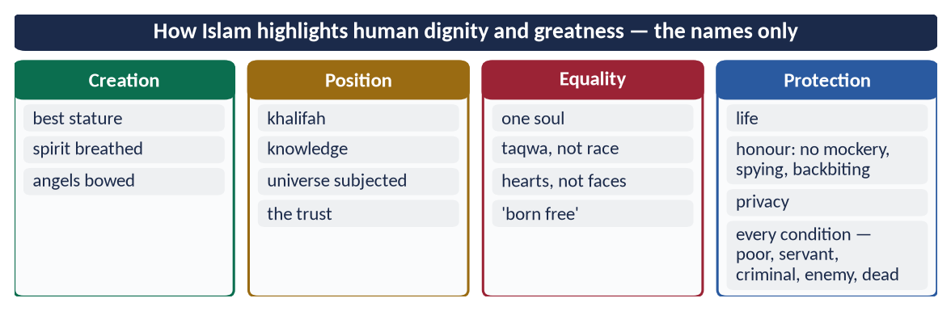
Figure 9 · At a glance — how Islam highlights human dignity and greatness — the names only. The detail is in the sections above.

(7) The scholars
✦ SCHOLARLY VIEW
Allama Muhammad Iqbal · Asrar-e-Khudi; Bal-e-Jibril
Iqbal's philosophy of khudi teaches that man, as the vicegerent of God, grows great by strengthening his self through faith, action and struggle — 'Khudi ko kar buland itna…'.
➜ Greatness is a potential to be developed.

✦ SCHOLARLY VIEW
Imam al-Ghazali · Al-Mustasfa
The Shari'ah protects five essentials — faith, life, intellect, lineage and property — the whole law is a shield around human dignity.
➜ Dignity is the aim of the law.

(8) Dignity carries responsibility
✦ QURAN
﴿ثُمَّ رَدَدۡنَٰهُ أَسۡفَلَ سَٰفِلِينَ ۝ إِلَّا ٱلَّذِينَ ءَامَنُواْ وَعَمِلُواْ ٱلصَّـٰلِحَٰتِ فَلَهُمۡ أَجۡرٌ غَيۡرُ مَمۡنُونٖ﴾
“Then We return him to the lowest of the low. Except for those who believe and do righteous deeds, for they will have a reward uninterrupted.” (At-Tin, Quran)
➜ Then We return him to the lowest of the low — except those who believe and do good deeds.

Man's dignity is given; his greatness is earned through faith, knowledge and good deeds. The same human being can rise above the angels or fall below the animals.

(9) Conclusion
Islam highlights human dignity by the way man was created, the position he was given, the equality of all humans, and the laws that protect his life, honour and privacy — even after death. In an age of racism, exploitation and the degradation of human beings by war and poverty, this vision is the most needed message Islam has for the world.

Why this answer scores
- It answers 'how' — the ways and sources — in clear headings.
- It separates dignity (given to all) and greatness (position and potential).
- The responsibility section (At-Tin 5–6) and the scholars add depth.

Answer 5 · Islam and the UDHR: A Comparative and Critical Analysis (CSS 2026)
THE QUESTION · CSS 2026 · Q2 · 20 marks
Provide a comparative and critical analysis of the human rights granted by Islam with those enshrined in the Universal Declaration of Human Rights (UDHR).

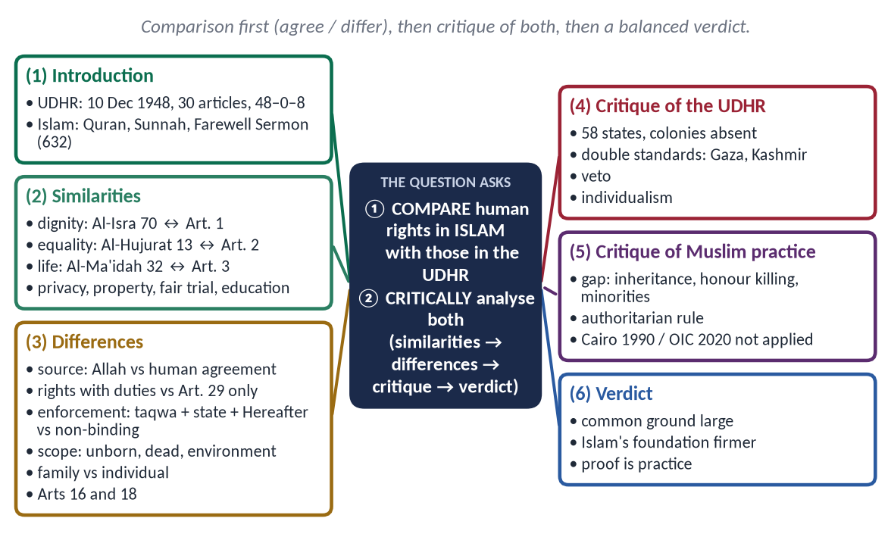
Figure 10 · The answer map: every branch is one numbered heading of the model answer below.

Decoding the question
- 'Comparative' = similarities and differences, point by point.
- 'Critical' = judge the strengths and weaknesses of both — including Muslim practice.
- 'Human rights granted by Islam' vs 'enshrined in the UDHR' — use both the texts and their application.

The model answer

(1) Introduction
The Universal Declaration of Human Rights was adopted by the UN General Assembly on 10 December 1948 — a preamble and 30 articles, passed 48–0 with 8 abstentions; Pakistan voted in favour. Islam declared human rights thirteen centuries earlier, in the Quran, the Sunnah, the Charter of Madinah and the Farewell Sermon (632). Muslim states restated them in the Cairo Declaration (1990) and the OIC Declaration on Human Rights (2020).
Figure 11 · From the Farewell Sermon to the UDHR and the OIC declarations.

(2) The similarities
Right | Islam | UDHR
Dignity | Al-Isra 70 | Preamble; Article 1
Equality | Al-Hujurat 13; Farewell Sermon | Articles 1, 2, 7
Life and security | Al-Ma'idah 32 | Article 3
No torture | Ban on mutilation (Muslim) | Article 5
Fair trial | Al-Hujurat 6; 'the burden of proof is on the claimant' (Al-Tirmidhi) | Articles 10, 11
Privacy | An-Nur 27; Al-Hujurat 12 | Article 12
Asylum | At-Tawbah 6 | Article 14
Property | An-Nisa 29 | Article 17
Work and fair wage | 'Wage before sweat dries' (Ibn Majah) | Article 23
Education | 'Seeking knowledge is obligatory' (Ibn Majah) | Article 26

On most rights, Islam and the UDHR agree.

(3) The differences

(i) Source
- UDHR: human agreement; what states grant, states can change.
- Islam: Allah — rights cannot be cancelled by any ruler or majority.
✦ QURAN
﴿وَلَقَدۡ كَرَّمۡنَا بَنِيٓ ءَادَمَ وَحَمَلۡنَٰهُمۡ فِي ٱلۡبَرِّ وَٱلۡبَحۡرِ وَرَزَقۡنَٰهُم مِّنَ ٱلطَّيِّبَٰتِ وَفَضَّلۡنَٰهُمۡ عَلَىٰ كَثِيرٖ مِّمَّنۡ خَلَقۡنَا تَفۡضِيلٗا﴾
“And We have certainly honored the children of Adam and carried them on the land and sea and provided for them of the good things and preferred them over much of what We have created, with [definite] preference.” (Al-Isra, Quran)
➜ Dignity comes from Allah: 'We have honoured the children of Adam.'

(ii) Rights and duties
- UDHR: duties appear only in Article 29.
- Islam: every right is someone's duty — parents and children, husband and wife, ruler and ruled.

(iii) Enforcement
- UDHR: a non-binding declaration; enforcement depends on states and the Security Council, where five powers hold a veto.
- Islam: conscience (taqwa), the state and the Hereafter — the rights of people are not forgiven until the wronged forgive.

(iv) Scope
- Islam also protects the unborn, the dead ('breaking a dead man's bone is like breaking it alive' — Abu Dawud), animals, the environment and future generations.

(v) Individual and family
- UDHR: centred on the individual.
- Islam: the individual within family and society; the family is protected as sacred.

(vi) Limits of freedom
- UDHR: limited by law, public order and morality (Article 29(2)).
- Islam: freedom within the limits of Allah — no freedom to spread indecency, blaspheme or harm oneself.

(vii) Points of tension
Many Muslim states made reservations on Article 16 (marriage without religious limitation) and Article 18 (freedom to change religion), because marriage and apostasy fall under Islamic family and public law — while Islam affirms that there is no compulsion in accepting faith.

(4) Critical analysis of the UDHR and its practice
- (a) Not truly universal in origin: 58 UN members in 1948; most of Asia and Africa were colonies with no voice.
- (b) Double standards: rights enforced selectively — Palestine, Gaza, Kashmir ignored.
- (c) The veto blocks action on violations by powerful states.
- (d) Individualism without moral limits has weakened the family.
- (e) Rights without duties encourage a culture of claims.

(5) Critical analysis of Muslim practice
- (a) The gap: denial of women's inheritance, honour killings, forced marriage, child labour, mistreatment of minorities, torture in custody — all against Islam.
- (b) Authoritarian rule denies 'a word of justice before a tyrant ruler'.
- (c) The Cairo (1990) and OIC (2020) declarations are weakly implemented.
PAKISTAN · BOTH STANDARDS IN ONE CONSTITUTION
Pakistan's Fundamental Rights (Articles 8–28) reflect the UDHR; the Objectives Resolution and Article 227 tie laws to the Quran and Sunnah. The country's record — on women, minorities and enforced disappearances — is judged by both standards.

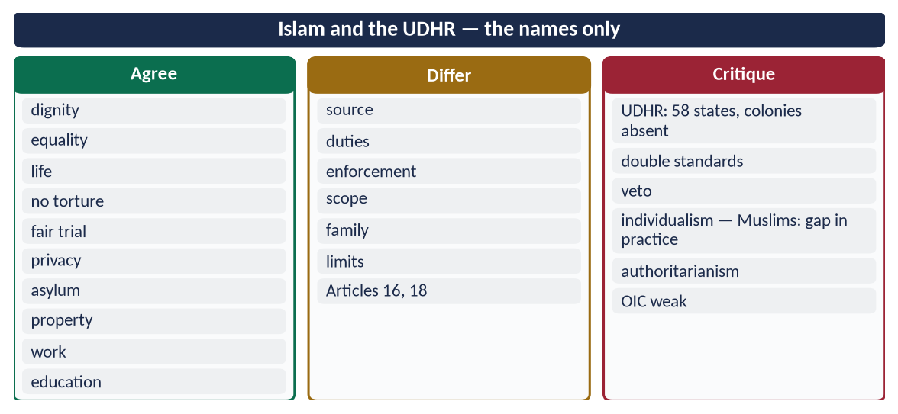
Figure 12 · At a glance — islam and the UDHR — the names only. The detail is in the sections above.

(6) Verdict and conclusion
✦ QURAN
﴿يَـٰٓأَيُّهَا ٱلَّذِينَ ءَامَنُواْ كُونُواْ قَوَّـٰمِينَ بِٱلۡقِسۡطِ شُهَدَآءَ لِلَّهِ وَلَوۡ عَلَىٰٓ أَنفُسِكُمۡ أَوِ ٱلۡوَٰلِدَيۡنِ وَٱلۡأَقۡرَبِينَۚ …﴾
“O you who believe, stand firmly for justice, as witnesses for Allah, even if it be against yourselves, your parents or your relatives.” (An-Nisa, Quran)
➜ 'Stand firm for justice, as witnesses for Allah, even against yourselves.'

The UDHR is a great human achievement and agrees with Islam on most rights. Islam gives them a firmer foundation (Allah), a fuller scope, a balance of rights and duties and a moral enforcement no declaration can supply. But neither text protects anyone by itself: the UDHR is weakened by double standards, and the Islamic claim by Muslim practice. The strongest Muslim answer to the UDHR is not a better document — it is better practice.

Why this answer scores
- Comparative: a ten-row table of similarities and seven headed differences.
- Critical: critiques of both the UDHR and Muslim practice — the balance examiners reward.
- Hard facts: 1948, 30 articles, 48–0–8, 58 states, Articles 16, 18, 29.

Answer 6 · Human Rights in Islamic Thought, with the Status of Women (CSS 2022)
THE QUESTION · CSS 2022 · Q2 · 20 marks
Explain the concept of Human Rights in Islamic thought in specification of "Status of Women in Islam".

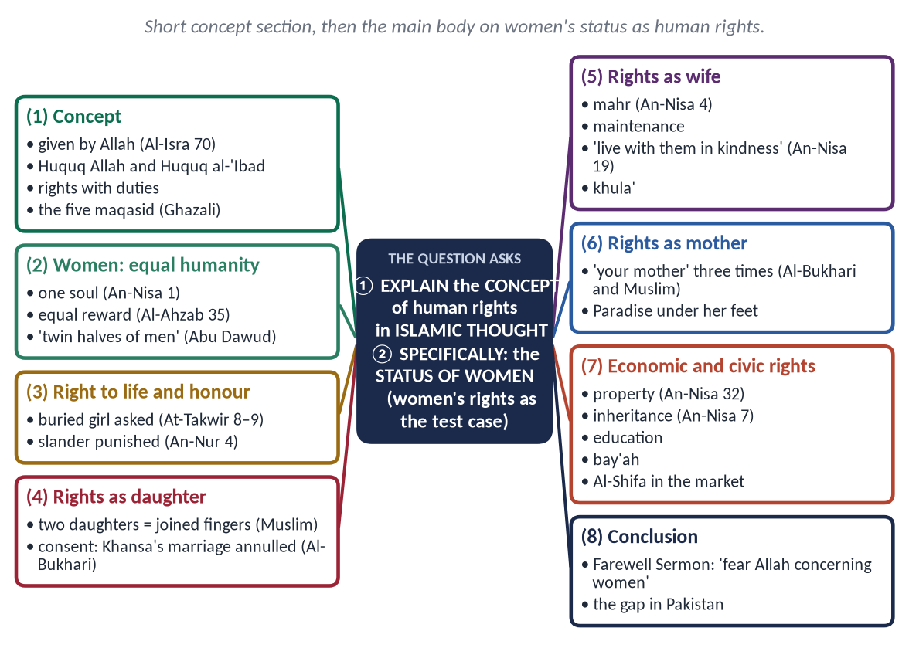
Figure 13 · The answer map: every branch is one numbered heading of the model answer below.

Decoding the question
- 'Concept of human rights in Islamic thought' — a short, clear framework: source, kinds, features, maqasid.
- 'In specification of the status of women' — the main body: women's rights as human rights.
- Give roughly one-third to the concept and two-thirds to women.

The model answer

(1) Introduction
✦ QURAN
﴿وَلَقَدۡ كَرَّمۡنَا بَنِيٓ ءَادَمَ وَحَمَلۡنَٰهُمۡ فِي ٱلۡبَرِّ وَٱلۡبَحۡرِ وَرَزَقۡنَٰهُم مِّنَ ٱلطَّيِّبَٰتِ وَفَضَّلۡنَٰهُمۡ عَلَىٰ كَثِيرٖ مِّمَّنۡ خَلَقۡنَا تَفۡضِيلٗا﴾
“And We have certainly honored the children of Adam and carried them on the land and sea and provided for them of the good things and preferred them over much of what We have created, with [definite] preference.” (Al-Isra, Quran)
➜ 'We have honoured the children of Adam' — dignity given to every human being, man or woman.

In Islamic thought, human rights are not a gift of states but a trust from Allah. The clearest test of any human-rights system is how it treats women — and here Islam made one of the greatest reforms in history.

(2) The concept of human rights in Islamic thought

(i) Source and nature
Rights are given by Allah through the Quran and Sunnah; they are permanent, universal and joined with duties.

(ii) Two kinds of rights
Huquq Allah (حُقُوقُ الله) and Huquq al-'Ibad (حُقُوقُ الْعِبَاد) — the rights of people are not forgiven until the wronged person forgives.

(iii) The framework — the Maqasid al-Shari'ah
✦ SCHOLARLY VIEW
Imam al-Ghazali · Al-Mustasfa
The Shari'ah aims to protect five essentials — faith, life, intellect, lineage and property.
➜ Every human right falls under one of these.

(iv) The charter
The Farewell Sermon: 'Your lives, property and honour are sacred' (Al-Bukhari).

(3) The status of women as human beings
✦ QURAN
﴿يَـٰٓأَيُّهَا ٱلنَّاسُ ٱتَّقُواْ رَبَّكُمُ ٱلَّذِي خَلَقَكُم مِّن نَّفۡسٖ وَٰحِدَةٖ وَخَلَقَ مِنۡهَا زَوۡجَهَا وَبَثَّ مِنۡهُمَا رِجَالٗا كَثِيرٗا وَنِسَآءٗۚ …﴾
“O mankind, fear your Lord, who created you from one soul, created from it its mate, and spread from both of them many men and women.” (An-Nisa, Quran)
➜ Men and women were created from one soul.

✦ QURAN
﴿إِنَّ ٱلۡمُسۡلِمِينَ وَٱلۡمُسۡلِمَٰتِ وَٱلۡمُؤۡمِنِينَ وَٱلۡمُؤۡمِنَٰتِ وَٱلۡقَٰنِتِينَ وَٱلۡقَٰنِتَٰتِ وَٱلصَّـٰدِقِينَ وَٱلصَّـٰدِقَٰتِ وَٱلصَّـٰبِرِينَ وَٱلصَّـٰبِرَٰتِ وَٱلۡخَٰشِعِينَ وَٱلۡخَٰشِعَٰتِ وَٱلۡمُتَصَدِّقِينَ وَٱلۡمُتَصَدِّقَٰتِ وَٱلصَّـٰٓئِمِينَ وَٱلصَّـٰٓئِمَٰتِ وَٱلۡحَٰفِظِينَ فُرُوجَهُمۡ وَٱلۡحَٰفِظَٰتِ وَٱلذَّـٰكِرِينَ ٱللَّهَ كَثِيرٗا وَٱلذَّـٰكِرَٰتِ أَعَدَّ ٱللَّهُ لَهُم مَّغۡفِرَةٗ وَأَجۡرًا عَظِيمٗا﴾
“Indeed, the Muslim men and Muslim women, the believing men and believing women, the obedient men and obedient women, the truthful men and truthful women, the patient men and patient women, the humble men and humble women, the charitable men and charitable women, the fasting men and fasting women, the men who guard their private parts and the women who do so, and the men who remember Allah often and the women who do so - for them Allah has prepared forgiveness and a great reward.” (Al-Ahzab, Quran)
➜ The same forgiveness and great reward for believing men and women.

✦ HADITH
إِنَّمَا النِّسَاءُ شَقَائِقُ الرِّجَالِ
“Women are the twin halves of men.” (Abu Dawud and Al-Tirmidhi)
➜ Equal in humanity and dignity.

Before Islam, girls were buried alive and women were inherited like property; Islam made them persons with rights.

(4) The rights of women

(i) Right to life and honour
✦ QURAN
﴿وَإِذَا ٱلۡمَوۡءُۥدَةُ سُئِلَتۡ ۝ بِأَيِّ ذَنۢبٖ قُتِلَتۡ﴾
“And when the girl [who was] buried alive is asked. For what sin she was killed.” (At-Takwir, Quran)
➜ The girl buried alive will be asked for what sin she was killed.

A false accusation against a chaste woman carries eighty lashes (An-Nur 4).

(ii) Rights as a daughter
✦ HADITH
مَنْ عَالَ جَارِيَتَيْنِ حَتَّى تَبْلُغَا، جَاءَ يَوْمَ الْقِيَامَةِ أَنَا وَهُوَ — وَضَمَّ أَصَابِعَهُ
“Whoever raises two daughters until they grow up will be with me on the Day of Resurrection like this — and he joined his fingers.” (Muslim)

Consent in marriage: when Khansa bint Khidam was married against her will, the Prophet ﷺ annulled it (Al-Bukhari).

(iii) Rights as a wife
✦ QURAN
﴿وَءَاتُواْ ٱلنِّسَآءَ صَدُقَٰتِهِنَّ نِحۡلَةٗۚ فَإِن طِبۡنَ لَكُمۡ عَن شَيۡءٖ مِّنۡهُ نَفۡسٗا فَكُلُوهُ هَنِيٓـٔٗا مَّرِيٓـٔٗا﴾
“And give the women [upon marriage] their [bridal] gifts graciously. But if they give up willingly to you anything of it, then take it in satisfaction and ease.” (An-Nisa, Quran)
➜ Give women their mahr as a free gift.

✦ QURAN
﴿… وَعَاشِرُوهُنَّ بِٱلۡمَعۡرُوفِۚ …﴾
“And live with them in kindness.” (An-Nisa, Quran)
➜ 'Live with them in kindness.'

✦ QURAN
﴿… وَلَهُنَّ مِثۡلُ ٱلَّذِي عَلَيۡهِنَّ بِٱلۡمَعۡرُوفِۚ وَلِلرِّجَالِ عَلَيۡهِنَّ دَرَجَةٞۗ …﴾
“And women have rights similar to their obligations, according to what is reasonable; and men have a degree over them.” (Al-Baqarah, Quran)
➜ Women have rights like their obligations, according to what is reasonable.

Maintenance by the husband; the right to khula' (the wife of Thabit ibn Qays — Al-Bukhari).

(iv) Rights as a mother
✦ HADITH
أُمُّكَ، ثُمَّ أُمُّكَ، ثُمَّ أُمُّكَ، ثُمَّ أَبُوكَ
“Your mother, then your mother, then your mother, then your father.” (Al-Bukhari and Muslim)

(v) Economic rights
✦ QURAN
﴿… لِّلرِّجَالِ نَصِيبٞ مِّمَّا ٱكۡتَسَبُواْۖ وَلِلنِّسَآءِ نَصِيبٞ مِّمَّا ٱكۡتَسَبۡنَۚ …﴾
“For men is a share of what they have earned, and for women is a share of what they have earned.” (An-Nisa, Quran)
➜ For women is a share of what they have earned.

✦ QURAN
﴿لِّلرِّجَالِ نَصِيبٞ مِّمَّا تَرَكَ ٱلۡوَٰلِدَانِ وَٱلۡأَقۡرَبُونَ وَلِلنِّسَآءِ نَصِيبٞ مِّمَّا تَرَكَ ٱلۡوَٰلِدَانِ وَٱلۡأَقۡرَبُونَ مِمَّا قَلَّ مِنۡهُ أَوۡ كَثُرَۚ نَصِيبٗا مَّفۡرُوضٗا﴾
“For men is a share of what the parents and close relatives leave, and for women is a share of what the parents and close relatives leave, be it little or much - an obligatory share.” (An-Nisa, Quran)
➜ For women is a share of inheritance — little or much, an obligatory share.

(vi) Education and civic life
Knowledge obligatory on every Muslim (Ibn Majah); Hazrat Aishah (RA) taught the senior Companions; women gave the bay'ah (Al-Mumtahanah 12); Al-Shifa bint Abdullah supervised the market under Umar (RA).
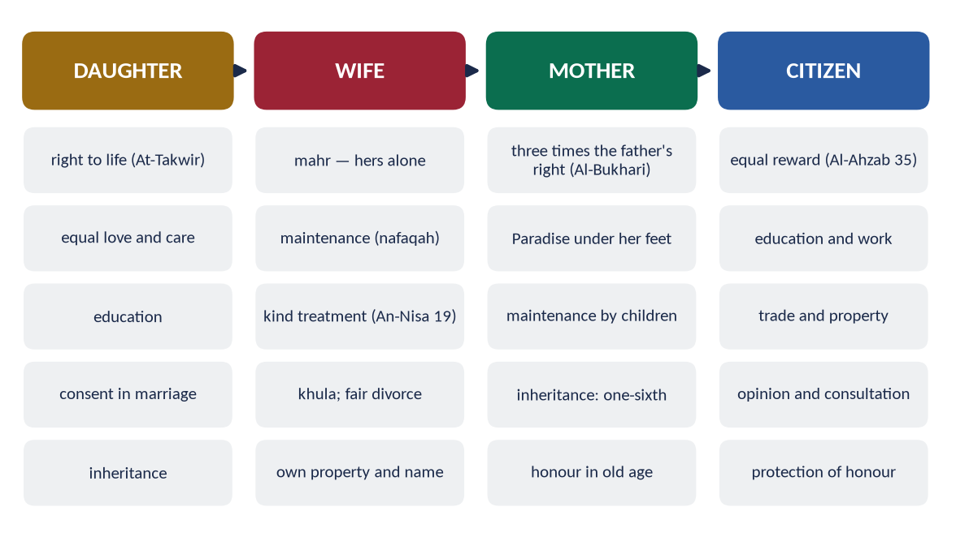
Figure 14 · The rights of the woman as daughter, wife, mother and citizen.

(5) The gap in practice — Pakistan
Denial of inheritance, forced marriage, honour killing and low female literacy come from custom, not Islam. Pakistani law now punishes them — the 2011 Anti-Women Practices Act, the 2016 honour-killing law, the 2020 property-rights Act — and the Constitution guarantees equality (Article 25) and women's participation (Article 34).

(6) Conclusion
✦ HADITH
فَاتَّقُوا اللَّهَ فِي النِّسَاءِ، فَإِنَّكُمْ أَخَذْتُمُوهُنَّ بِأَمَانِ اللَّهِ
“Fear Allah concerning women; you have taken them as a trust from Allah.” (Muslim)
➜ The Farewell Sermon's word on women.

Human rights in Islamic thought are divine, balanced and enforced by conscience; the status of women shows this concept at its best — equal humanity, protected life and honour, economic independence and respect at every stage of life. The task today is to close the gap between this teaching and Muslim practice.

Why this answer scores
- The concept is explained briefly and clearly; women receive the main weight, as 'in specification of' demands.
- Women's rights are organised by life stage and kind — easy to follow and mark.
- The Pakistan gap shows honesty.

Answer 7 · Islam Provides Better Rights to Men and Women than All Other Religions (CSS 2021)
THE QUESTION · CSS 2021 · Q3 · 20 marks
Islam provides better rights to men and women than all other religions. Explore with arguments.

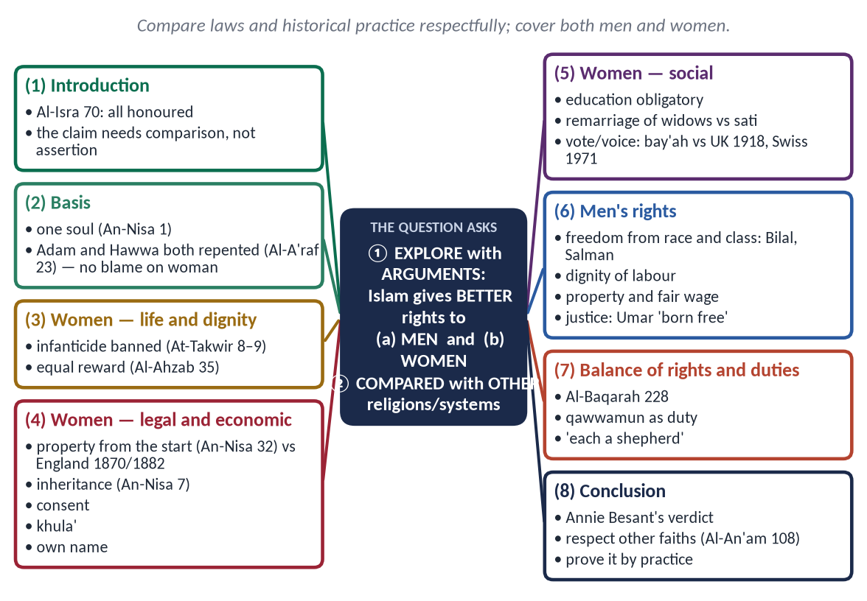
Figure 15 · The answer map: every branch is one numbered heading of the model answer below.

Decoding the question
- 'Explore with arguments' = a reasoned comparison, with evidence.
- 'Men and women' — both, not women only.
- 'Other religions' — compare laws and historical practices with respect; do not mock scriptures or founders.

The model answer

(1) Introduction
✦ QURAN
﴿وَلَقَدۡ كَرَّمۡنَا بَنِيٓ ءَادَمَ وَحَمَلۡنَٰهُمۡ فِي ٱلۡبَرِّ وَٱلۡبَحۡرِ وَرَزَقۡنَٰهُم مِّنَ ٱلطَّيِّبَٰتِ وَفَضَّلۡنَٰهُمۡ عَلَىٰ كَثِيرٖ مِّمَّنۡ خَلَقۡنَا تَفۡضِيلٗا﴾
“And We have certainly honored the children of Adam and carried them on the land and sea and provided for them of the good things and preferred them over much of what We have created, with [definite] preference.” (Al-Isra, Quran)
➜ 'We have honoured the children of Adam.'

The claim that Islam gives better rights than other religions can be proved only by comparison — of what Islam established in the seventh century with the laws and customs of other religious civilisations, many of which changed only in the last two centuries. The comparison below is made with respect, as the Quran commands (Al-An'am 108).

(2) The basis — one humanity, no blame on woman
✦ QURAN
﴿يَـٰٓأَيُّهَا ٱلنَّاسُ ٱتَّقُواْ رَبَّكُمُ ٱلَّذِي خَلَقَكُم مِّن نَّفۡسٖ وَٰحِدَةٖ وَخَلَقَ مِنۡهَا زَوۡجَهَا وَبَثَّ مِنۡهُمَا رِجَالٗا كَثِيرٗا وَنِسَآءٗۚ …﴾
“O mankind, fear your Lord, who created you from one soul, created from it its mate, and spread from both of them many men and women.” (An-Nisa, Quran)
➜ All created from one soul and its mate.

✦ QURAN
﴿قَالَا رَبَّنَا ظَلَمۡنَآ أَنفُسَنَا وَإِن لَّمۡ تَغۡفِرۡ لَنَا وَتَرۡحَمۡنَا لَنَكُونَنَّ مِنَ ٱلۡخَٰسِرِينَ﴾
“They said, "Our Lord, we have wronged ourselves, and if You do not forgive us and have mercy upon us, we will surely be among the losers.” (Al-A'raf, Quran)
➜ Adam and Hawwa both said: 'Our Lord, we have wronged ourselves' — both repented and were forgiven.

Islam does not blame woman for the fall of man — a view that shaped the treatment of women in many societies.

(3) Better rights for women — the comparison
Right | Islam (7th century) | Elsewhere
Life | Burial of girls banned (At-Takwir 8–9) | Infanticide practised in several ancient societies
Spiritual equality | Same reward (Al-Ahzab 35) | Women excluded from priesthood and many rites
Consent to marriage | Required; forced marriage annulled (Al-Bukhari) | Arranged without consent widely
Own property | From the start (An-Nisa 32) | England: Married Women's Property Acts, 1870 and 1882
Inheritance | Fixed share (An-Nisa 7, 11) | Excluded or reduced in many laws until modern times
Divorce | Khula' for the wife (Al-Baqarah 229) | Nearly impossible in many systems until the 20th century
Widow remarriage | Allowed; the Prophet ﷺ married widows | Sati in India (abolished 1829); remarriage barred
Education | Obligatory for every Muslim (Ibn Majah) | Universities opened to women mainly in the 19th century
Public voice | Women gave the bay'ah (Al-Mumtahanah 12) | Vote: UK 1918/1928; USA 1920; Switzerland 1971
Own name | Keeps her father's name | Takes the husband's name by custom or law in many places

✦ QURAN
﴿لِّلرِّجَالِ نَصِيبٞ مِّمَّا تَرَكَ ٱلۡوَٰلِدَانِ وَٱلۡأَقۡرَبُونَ وَلِلنِّسَآءِ نَصِيبٞ مِّمَّا تَرَكَ ٱلۡوَٰلِدَانِ وَٱلۡأَقۡرَبُونَ مِمَّا قَلَّ مِنۡهُ أَوۡ كَثُرَۚ نَصِيبٗا مَّفۡرُوضٗا﴾
“For men is a share of what the parents and close relatives leave, and for women is a share of what the parents and close relatives leave, be it little or much - an obligatory share.” (An-Nisa, Quran)
➜ For women is a share of what parents and relatives leave — little or much, an obligatory share.

✦ HADITH
أُمُّكَ، ثُمَّ أُمُّكَ، ثُمَّ أُمُّكَ، ثُمَّ أَبُوكَ
“Your mother, then your mother, then your mother, then your father.” (Al-Bukhari and Muslim)
➜ The mother placed above the father three times.

✦ SCHOLARLY VIEW
Annie Besant · The Life and Teachings of Muhammad (1932)
Besant noted that the Muslim woman held legal rights over her property from the beginning, and judged her in this respect freer under Islamic law than women in the West of her time.
➜ A Western reformer's verdict.

(4) Better rights for men

(i) Freedom from racial and class hierarchy
Where caste and aristocracy fixed a man's worth at birth, Islam declared: 'No Arab over a non-Arab … except by taqwa' (Ahmad). Bilal the Abyssinian gave the adhan on the Ka'bah; Salman the Persian was 'of the people of the house'.

(ii) Dignity of labour and fair wages
✦ HADITH
أَعْطُوا الْأَجِيرَ أَجْرَهُ قَبْلَ أَنْ يَجِفَّ عَرَقُهُ
“Give the worker his wage before his sweat dries.” (Ibn Majah)

(iii) Equality before the law
Umar (RA) to his governor, whose son had struck an Egyptian commoner: 'Since when have you enslaved people whose mothers bore them free?'

(iv) Freedom of conscience and expression
✦ QURAN
﴿لَآ إِكۡرَاهَ فِي ٱلدِّينِۖ قَد تَّبَيَّنَ ٱلرُّشۡدُ مِنَ ٱلۡغَيِّۚ …﴾
“There is no compulsion in religion; the right course has become clear from the wrong.” (Al-Baqarah, Quran)
➜ No compulsion in religion.

'The best jihad is a word of justice before a tyrant ruler' (Abu Dawud) — the right to speak truth to power.

(v) Freedom from priestly control
No priesthood stands between man and Allah; every man and woman prays directly to Him (Al-Baqarah 186).

(5) The balance of rights and duties
✦ QURAN
﴿… وَلَهُنَّ مِثۡلُ ٱلَّذِي عَلَيۡهِنَّ بِٱلۡمَعۡرُوفِۚ وَلِلرِّجَالِ عَلَيۡهِنَّ دَرَجَةٞۗ …﴾
“And women have rights similar to their obligations, according to what is reasonable; and men have a degree over them.” (Al-Baqarah, Quran)
➜ Women have rights like their obligations — rights on both sides.

Men are qawwamun (An-Nisa 34) — a duty to protect and maintain, balanced by the wife's rights to mahr, maintenance and kindness. 'Each of you is a shepherd and each is responsible for his flock' (Al-Bukhari).
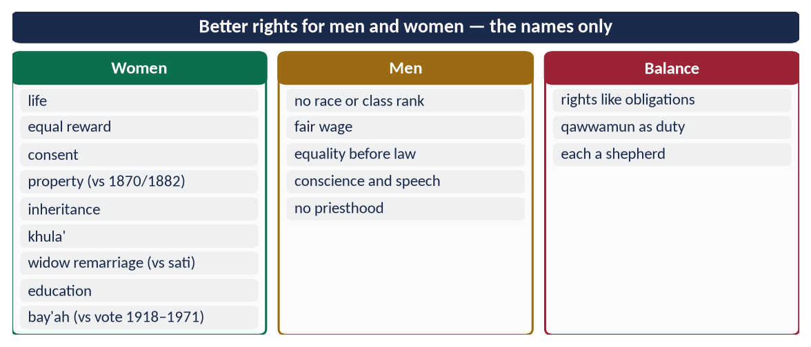
Figure 16 · At a glance — better rights for men and women — the names only. The detail is in the sections above.

(6) An honest limit
Rights given in the text are not always given in practice: denial of inheritance and forced marriage in Muslim societies are custom, not Islam. The argument for Islam's superiority is strongest when Muslims live it.

(7) Conclusion
✦ QURAN
﴿مَنۡ عَمِلَ صَٰلِحٗا مِّن ذَكَرٍ أَوۡ أُنثَىٰ وَهُوَ مُؤۡمِنٞ فَلَنُحۡيِيَنَّهُۥ حَيَوٰةٗ طَيِّبَةٗۖ وَلَنَجۡزِيَنَّهُمۡ أَجۡرَهُم بِأَحۡسَنِ مَا كَانُواْ يَعۡمَلُونَ﴾
“Whoever does righteousness, whether male or female, while he is a believer - We will surely cause him to live a good life, and We will surely give them their reward [in the Hereafter] according to the best of what they used to do.” (An-Nahl, Quran)
➜ Whoever does good, male or female, while a believer — We will give him a good life.

Compared with the laws and customs of other religious civilisations, Islam gave women life, property, inheritance, consent, divorce and education centuries earlier, and gave men freedom from caste, dignity of labour, equality before the law and direct access to God. It did so with a balance of rights and duties that protects the family. That is why the claim stands — provided Muslims prove it by practice.

Why this answer scores
- It compares — a ten-row table with dates — instead of merely claiming.
- It covers men and women, as the question says.
- It is respectful of other faiths and honest about Muslim practice.

Answer 8 · The Rights of Daughters in Islam and Their Denial by Muslims Today (CSS 2023)
THE QUESTION · CSS 2023 · Q4 · 20 marks
Elaborate the rights of daughters granted by Islam and how these are denied by Muslims in the contemporary world?

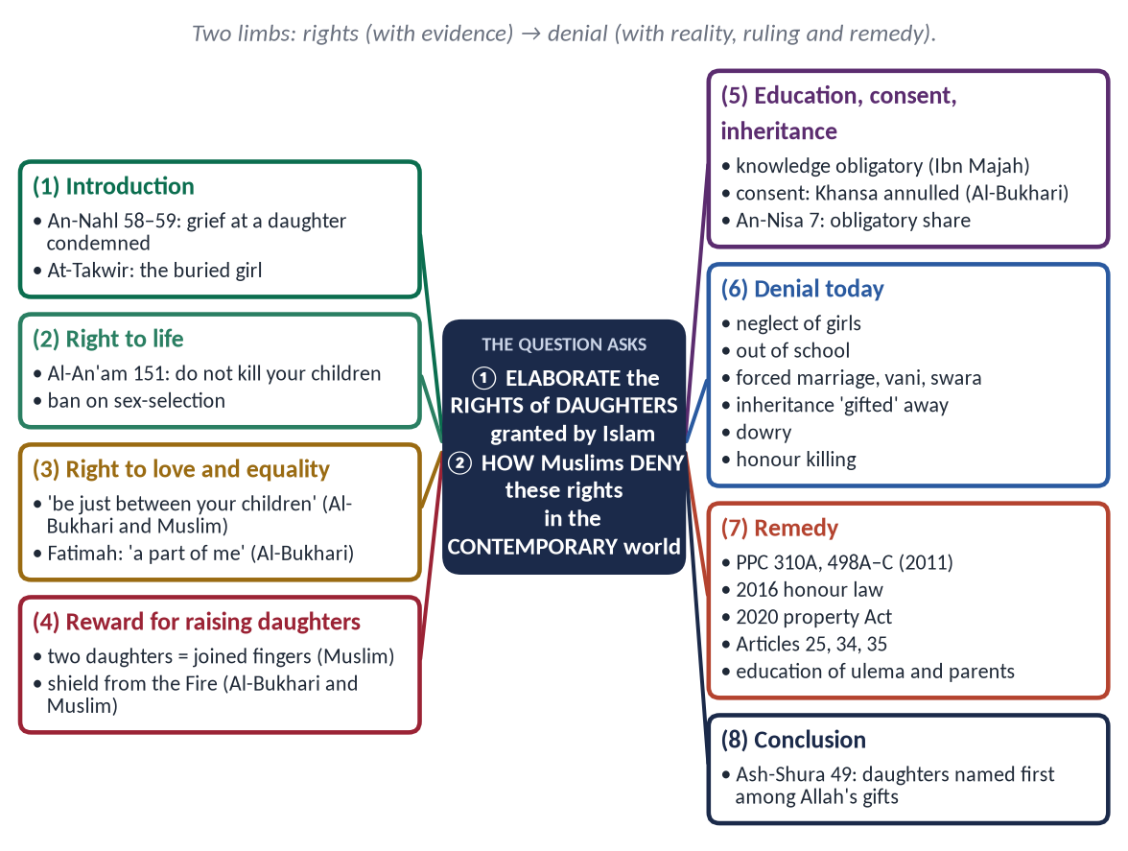
Figure 17 · The answer map: every branch is one numbered heading of the model answer below.

Decoding the question
- 'Elaborate the rights' = each right with its Quranic or Prophetic evidence.
- 'How these are denied by Muslims' = honest description of practices — with facts.
- 'Contemporary world' = today, especially Pakistan and South Asia.

The model answer

(1) Introduction
✦ QURAN
﴿وَإِذَا بُشِّرَ أَحَدُهُم بِٱلۡأُنثَىٰ ظَلَّ وَجۡهُهُۥ مُسۡوَدّٗا وَهُوَ كَظِيمٞ ۝ يَتَوَٰرَىٰ مِنَ ٱلۡقَوۡمِ مِن سُوٓءِ مَا بُشِّرَ بِهِۦٓۚ أَيُمۡسِكُهُۥ عَلَىٰ هُونٍ أَمۡ يَدُسُّهُۥ فِي ٱلتُّرَابِۗ أَلَا سَآءَ مَا يَحۡكُمُونَ﴾
“And when one of them is informed of [the birth of] a female, his face becomes dark, and he suppresses grief. He hides himself from the people because of the ill of which he has been informed. Should he keep it in humiliation or bury it in the ground? Unquestionably, evil is what they decide.” (An-Nahl, Quran)
➜ When one of them was told of the birth of a girl, his face darkened; should he keep her in humiliation or bury her in the dust? Evil is their judgement.

Islam came to a society that buried daughters alive. It turned the daughter from a source of shame into a gift of Allah and a path to Paradise. Yet fourteen centuries later, many Muslims still deny daughters the rights Islam gave them.

(2) The rights of daughters granted by Islam

(i) The right to life
✦ QURAN
﴿… وَلَا تَقۡتُلُوٓاْ أَوۡلَٰدَكُم مِّنۡ إِمۡلَٰقٖ نَّحۡنُ نَرۡزُقُكُمۡ وَإِيَّاهُمۡۖ …﴾
“Do not kill your children out of poverty; We provide for you and for them.” (Al-An'am, Quran)
➜ 'Do not kill your children out of poverty; We provide for you and for them.'

✦ QURAN
﴿وَإِذَا ٱلۡمَوۡءُۥدَةُ سُئِلَتۡ ۝ بِأَيِّ ذَنۢبٖ قُتِلَتۡ﴾
“And when the girl [who was] buried alive is asked. For what sin she was killed.” (At-Takwir, Quran)
➜ The girl buried alive will be asked for what sin she was killed.

(ii) A gift, not a burden
✦ QURAN
﴿لِّلَّهِ مُلۡكُ ٱلسَّمَٰوَٰتِ وَٱلۡأَرۡضِۚ يَخۡلُقُ مَا يَشَآءُۚ يَهَبُ لِمَن يَشَآءُ إِنَٰثٗا وَيَهَبُ لِمَن يَشَآءُ ٱلذُّكُورَ ۝ أَوۡ يُزَوِّجُهُمۡ ذُكۡرَانٗا وَإِنَٰثٗاۖ وَيَجۡعَلُ مَن يَشَآءُ عَقِيمًاۚ إِنَّهُۥ عَلِيمٞ قَدِيرٞ﴾
“To Allah belongs the dominion of the heavens and the earth; He creates what he wills. He gives to whom He wills female [children], and He gives to whom He wills males. Or He makes them [both] males and females, and He renders whom He wills barren. Indeed, He is Knowing and Competent.” (Ash-Shura, Quran)
➜ Allah gives daughters to whom He wills and sons to whom He wills — and daughters are mentioned first.

(iii) Love and equal treatment
✦ HADITH
اتَّقُوا اللَّهَ وَاعْدِلُوا بَيْنَ أَوْلَادِكُمْ
“Fear Allah and be just between your children.” (Al-Bukhari and Muslim)

✦ HADITH
فَاطِمَةُ بَضْعَةٌ مِنِّي، فَمَنْ أَغْضَبَهَا أَغْضَبَنِي
“Fatimah is a part of me; whoever angers her angers me.” (Al-Bukhari)
➜ He stood when she entered and seated her in his place.

(iv) Paradise for raising them well
✦ HADITH
مَنْ عَالَ جَارِيَتَيْنِ حَتَّى تَبْلُغَا، جَاءَ يَوْمَ الْقِيَامَةِ أَنَا وَهُوَ — وَضَمَّ أَصَابِعَهُ
“Whoever raises two daughters until they grow up will come on the Day of Resurrection with me like this — and he joined his fingers.” (Muslim)

✦ HADITH
مَنِ ابْتُلِيَ مِنْ هَذِهِ الْبَنَاتِ بِشَيْءٍ فَأَحْسَنَ إِلَيْهِنَّ كُنَّ لَهُ سِتْرًا مِنَ النَّارِ
“Whoever is tested with daughters and treats them well, they will be a shield for him from the Fire.” (Al-Bukhari and Muslim)

(v) Education and upbringing
✦ HADITH
طَلَبُ الْعِلْمِ فَرِيضَةٌ عَلَى كُلِّ مُسْلِمٍ
“Seeking knowledge is obligatory on every Muslim.” (Ibn Majah)

The Prophet ﷺ set a day for teaching women (Al-Bukhari); Hazrat Aishah (RA) became a teacher of the Ummah.

(vi) Consent in marriage
✦ HADITH
لَا تُنْكَحُ الْأَيِّمُ حَتَّى تُسْتَأْمَرَ، وَلَا تُنْكَحُ الْبِكْرُ حَتَّى تُسْتَأْذَنَ
“A previously married woman is not married without consultation, nor a virgin without her permission.” (Al-Bukhari and Muslim)

Khansa bint Khidam was married against her will; the Prophet ﷺ annulled the marriage (Al-Bukhari).

(vii) Mahr, maintenance and inheritance
✦ QURAN
﴿لِّلرِّجَالِ نَصِيبٞ مِّمَّا تَرَكَ ٱلۡوَٰلِدَانِ وَٱلۡأَقۡرَبُونَ وَلِلنِّسَآءِ نَصِيبٞ مِّمَّا تَرَكَ ٱلۡوَٰلِدَانِ وَٱلۡأَقۡرَبُونَ مِمَّا قَلَّ مِنۡهُ أَوۡ كَثُرَۚ نَصِيبٗا مَّفۡرُوضٗا﴾
“For men is a share of what the parents and close relatives leave, and for women is a share of what the parents and close relatives leave, be it little or much - an obligatory share.” (An-Nisa, Quran)
➜ For women is a share of inheritance — little or much, an obligatory share.

Her mahr is hers (An-Nisa 4); her father maintains her until marriage.
Figure 18 · A woman's rights at every stage — beginning as a daughter.

(3) How these rights are denied by Muslims today
Denial | What happens | Islamic ruling
Neglect at birth | Grief at a girl's birth; less food, care and health spending on girls | An-Nahl 58–59 condemns it
Education | About 26 million children out of school in Pakistan — girls the majority | Knowledge obligatory for all
Forced and early marriage | Marriage without consent; vani and swara — girls given to settle feuds | Consent required; Khansa's marriage annulled
Inheritance | Sisters pressed to 'gift' their share (haq bakhshwana) | An-Nisa 7; the limits of Allah (An-Nisa 13–14)
Dowry (jahez) | Parents in debt; girls unmarried | Not required; mahr is the husband's duty
Honour killing | Hundreds of cases a year (HRCP) | Murder (Al-Ma'idah 32)
Marriage to the Quran | To keep land in the family | A mockery of the Book
Unequal love | Sons preferred in gifts and attention | 'Be just between your children'

(4) Why — the causes
- Tribal and feudal custom (keeping land in the family).
- Poverty and the cost of dowry.
- Ignorance of Islam's teaching — custom mistaken for religion.
- Weak enforcement of law.

(5) The remedy
- Law: the Prevention of Anti-Women Practices Act 2011 — PPC 310A (vani, swara), 498A (denial of inheritance), 498B (forced marriage), 498C (marriage with the Quran); the 2016 honour-killing law; the Enforcement of Women's Property Rights Act 2020; Constitution Articles 25, 34, 35.
- Education: girls' schools; teaching the ulema and imams to preach these rights in Friday sermons.
- Society: simple marriages; ending dowry culture; honouring fathers of daughters.

(6) Conclusion
Islam made the daughter a gift, a trust and a road to Paradise, with rights to life, love, education, consent and inheritance. The practices that deny her these rights are not Islam but custom and greed, and Islam itself is the strongest argument against them. The Muslim who denies his daughter's rights opposes the Quran he recites.

Why this answer scores
- Both limbs answered: rights with evidence, and denial with facts, rulings and causes.
- The honest 'denied by Muslims' section is exactly what the examiner asked for.
- Pakistani law (2011, 2016, 2020) gives the answer contemporary depth.

Answer 9 · The Right of Inheritance Granted to Women by Islam (CSS 2017)
THE QUESTION · CSS 2017 · Q3 · 20 marks
Write a comprehensive note on the right of inheritance granted to women by Islam.

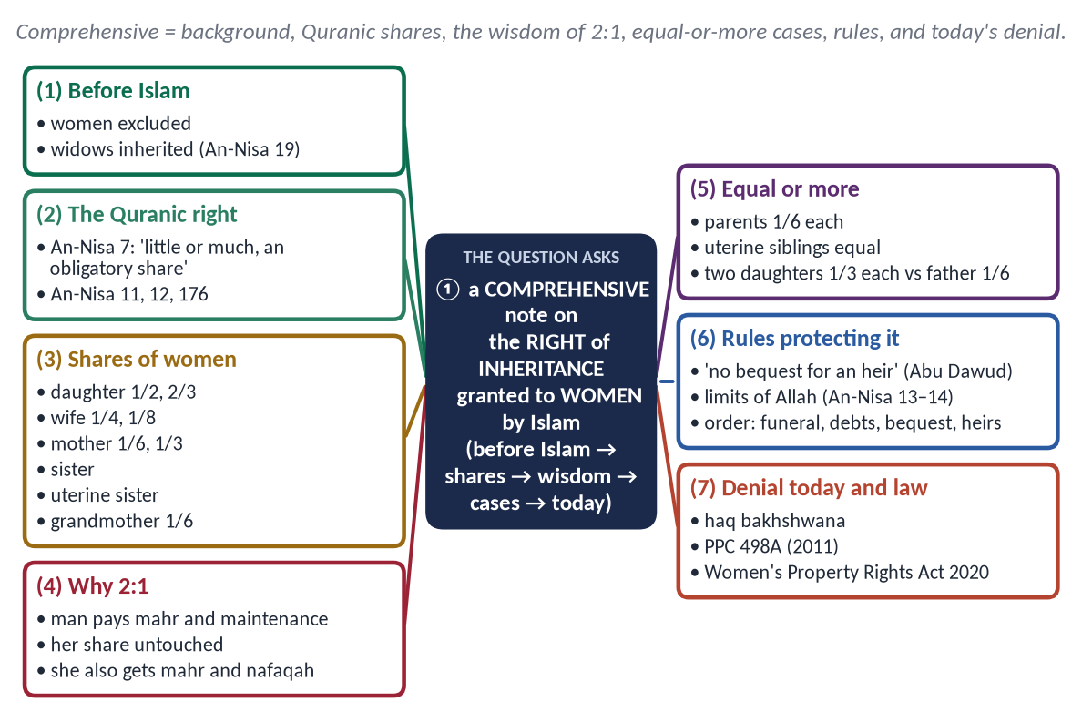
Figure 19 · The answer map: every branch is one numbered heading of the model answer below.

Decoding the question
- 'Comprehensive note' = all sides: background, the shares, the reason for differences, cases of equality, legal protections, and the present situation.
- Show figures and a table — this question rewards precision.

The model answer

(1) Introduction
Before Islam, Arab women inherited nothing; the rule was 'only he who carries the sword inherits'. Widows were themselves inherited by the husband's heirs.
✦ QURAN
﴿… وَعَاشِرُوهُنَّ بِٱلۡمَعۡرُوفِۚ …﴾
“And live with them in kindness.” (An-Nisa, Quran)
➜ It is not lawful for you to inherit women against their will.

Islam made the woman an heir in her own right — as daughter, wife, mother, sister and grandmother — and fixed her share in the Quran itself.

(2) The Quranic declaration of the right
✦ QURAN
﴿لِّلرِّجَالِ نَصِيبٞ مِّمَّا تَرَكَ ٱلۡوَٰلِدَانِ وَٱلۡأَقۡرَبُونَ وَلِلنِّسَآءِ نَصِيبٞ مِّمَّا تَرَكَ ٱلۡوَٰلِدَانِ وَٱلۡأَقۡرَبُونَ مِمَّا قَلَّ مِنۡهُ أَوۡ كَثُرَۚ نَصِيبٗا مَّفۡرُوضٗا﴾
“For men is a share of what the parents and close relatives leave, and for women is a share of what the parents and close relatives leave, be it little or much - an obligatory share.” (An-Nisa, Quran)
➜ For men is a share of what parents and relatives leave, and for women is a share — little or much, an obligatory share (nasiban mafrudan).

The occasion: the widow of Aws ibn Thabit (or, in another report, of Sa'd ibn al-Rabi') complained that her daughters had been left nothing; the verses of inheritance were revealed and their shares fixed (Abu Dawud; Al-Tirmidhi).

(3) The shares of women in the Quran
✦ QURAN
﴿يُوصِيكُمُ ٱللَّهُ فِيٓ أَوۡلَٰدِكُمۡۖ لِلذَّكَرِ مِثۡلُ حَظِّ ٱلۡأُنثَيَيۡنِۚ …﴾
“Allah instructs you concerning your children: for the male, the like of the share of two females.” (An-Nisa, Quran)
➜ Allah instructs you concerning your children: for the male, the like of the share of two females.

✦ QURAN
﴿… وَلَهُنَّ ٱلرُّبُعُ مِمَّا تَرَكۡتُمۡ إِن لَّمۡ يَكُن لَّكُمۡ وَلَدٞۚ فَإِن كَانَ لَكُمۡ وَلَدٞ فَلَهُنَّ ٱلثُّمُنُ مِمَّا تَرَكۡتُمۚ …﴾
“And for the wives is one-fourth of what you leave if you have no child; but if you have a child, then for them is one-eighth.” (An-Nisa, Quran)
➜ For the wives is one-fourth if you leave no child; one-eighth if you leave a child.

Heir | Share
Daughter | Alone: 1/2; two or more: 2/3 shared; with a son: half his share (An-Nisa 11)
Wife (one or more, shared) | 1/4 without children of the deceased; 1/8 with children (An-Nisa 12)
Mother | 1/6 with children or two+ siblings; otherwise 1/3 (An-Nisa 11)
Full sister | With no child or father: 1/2; two+: 2/3; with a brother: half his share (An-Nisa 176)
Uterine sister | 1/6; two+ share 1/3 equally with uterine brothers (An-Nisa 12)
Grandmother | 1/6 (Sunnah)

(4) Why a son receives twice a daughter — the wisdom
- (a) The man pays mahr and must maintain his wife, children and often parents and unmarried sisters; the woman must maintain no one, not even herself.
- (b) Her share is entirely hers; his is largely spent on others.
- (c) She gains from several sources — inheritance, mahr and maintenance.
- (d) The 2:1 rule applies only where a man and a woman stand in the same relation with the same duties — son and daughter, brother and sister, husband and wife; it is not a general rule for all women.

(5) Cases where women receive equal or more
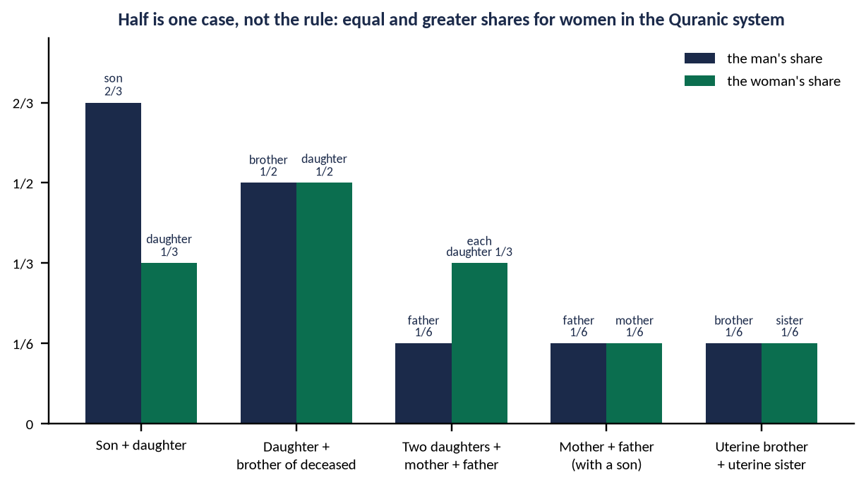
Figure 20 · Equal and greater shares for women.
- Father and mother of a deceased with a son: 1/6 each — equal.
- Uterine brother and sister: equal.
- Daughter with the deceased's brother: 1/2 each — equal.
- Two daughters with both parents: each daughter 1/3, father 1/6 — a woman receives twice a man.

(6) Rules that protect her share
✦ HADITH
إِنَّ اللَّهَ قَدْ أَعْطَى كُلَّ ذِي حَقٍّ حَقَّهُ، فَلَا وَصِيَّةَ لِوَارِثٍ
“Allah has given every rightful person his right; there is no bequest for an heir.” (Abu Dawud and Al-Tirmidhi)
➜ No one can cut her out by will.

✦ QURAN
﴿… وَمَن يَعۡصِ ٱللَّهَ وَرَسُولَهُۥ وَيَتَعَدَّ حُدُودَهُۥ يُدۡخِلۡهُ نَارًا خَٰلِدٗا فِيهَا وَلَهُۥ عَذَابٞ مُّهِينٞ﴾
“And whoever disobeys Allah and His Messenger and transgresses His limits — He will put him into the Fire to abide therein, and he will have a humiliating punishment.” (An-Nisa, Quran)
➜ Whoever disobeys Allah and transgresses His limits — the Fire; the warning that closes the inheritance verses.

Order of distribution (Hanafi): funeral expenses → debts (including her unpaid mahr) → bequest up to one-third, not to an heir → shares to the sharers, then the residuaries.

(7) The denial of women's inheritance today
In rural Pakistan, sisters and daughters are pressured to give up their share (haq bakhshwana), or are married within the family to keep the land.
- PPC 498A (2011): depriving a woman of inheritance by deceit or coercion — 5 to 10 years' imprisonment.
- Enforcement of Women's Property Rights Act 2020 — an ombudsperson to restore property quickly.
- The courts have held that a woman's relinquishment must be free and informed.
TRAP · 'HALF THE SHARE' IS NOT 'HALF THE VALUE'
Never write that Islam values a woman at half a man. Show the man's financial duties and the cases of equal or greater shares.

(8) Conclusion
Islam turned the woman from property that was inherited into an heir who inherits — with fixed shares no father, brother or will can remove. The 2:1 rule in one case is balanced by the man's financial duties, and in many cases she receives an equal or larger share. The real injustice today is not in the Quranic law but in its denial by custom — which Islam itself calls a transgression of the limits of Allah.

Why this answer scores
- Comprehensive: background, verses, a share table, wisdom, equal-share cases, legal rules and the present day.
- A figure and exact fractions show mastery.
- It answers the common objection (2:1) with facts.

Answer 10 · The Rights of Women in Islam and the Current Wave of Feminism (CSS 2019)
THE QUESTION · CSS 2019 · Q4 · 20 marks
Describe the rights of women in Islam in the context of current wave of the feminist movement.

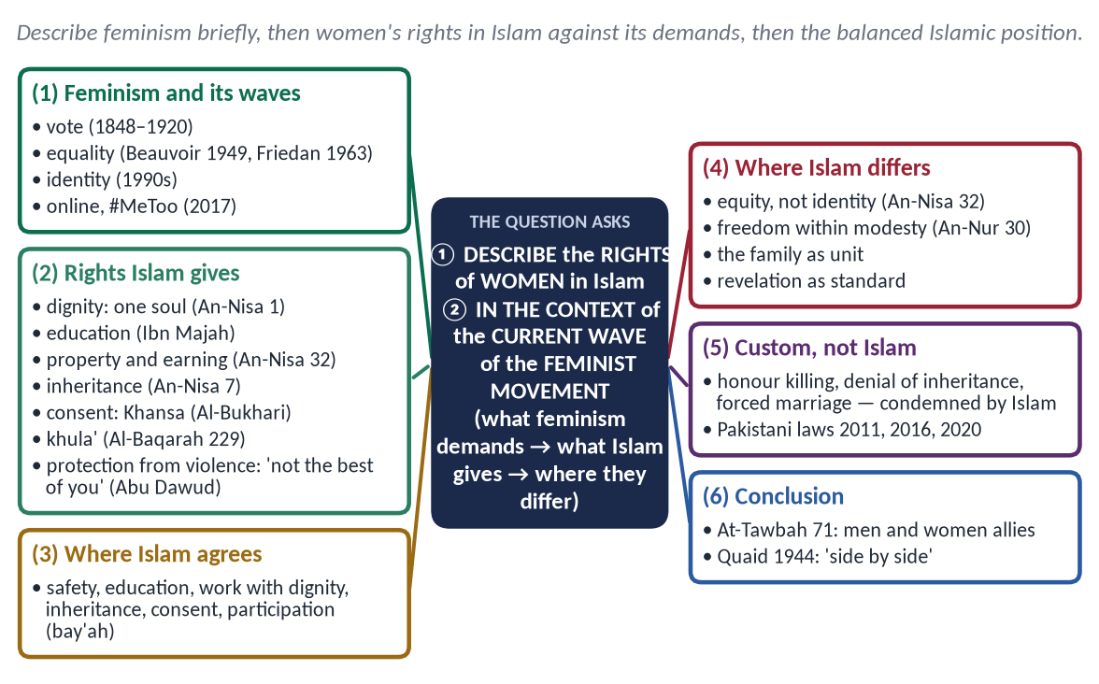
Figure 21 · The answer map: every branch is one numbered heading of the model answer below.

Decoding the question
- 'Describe the rights of women in Islam' — the main body.
- 'In the context of the current wave of the feminist movement' — show which demands of feminism Islam already meets, where it differs, and why.
- Avoid both extremes — rejecting every demand, or accepting every slogan.

The model answer

(1) Introduction
Feminism is the movement for the political, economic and social equality of women. Its current (fourth) wave, since about 2012, works through social media and street campaigns against harassment and violence (#MeToo, 2017) and for body autonomy. In Pakistan too, women's marches and online campaigns have made women's rights a national debate. Islam's answer is neither denial nor imitation: it gave women their rights fourteen centuries ago — within a framework of family and morality.

(2) The feminist movement — its waves
Wave | Period | Main demands
First | 1848–1920 | Vote and property (Seneca Falls, 1848)
Second | 1960s–1980s | Equal pay, education, family law (Beauvoir, 1949; Friedan, 1963)
Third | 1990s–2000s | Diversity, identity, choice
Fourth (current) | 2012 onwards | Online activism; harassment and violence (#MeToo, 2017); body autonomy

(3) The rights of women in Islam

(i) Equal humanity and dignity
✦ QURAN
﴿يَـٰٓأَيُّهَا ٱلنَّاسُ ٱتَّقُواْ رَبَّكُمُ ٱلَّذِي خَلَقَكُم مِّن نَّفۡسٖ وَٰحِدَةٖ وَخَلَقَ مِنۡهَا زَوۡجَهَا وَبَثَّ مِنۡهُمَا رِجَالٗا كَثِيرٗا وَنِسَآءٗۚ …﴾
“O mankind, fear your Lord, who created you from one soul, created from it its mate, and spread from both of them many men and women.” (An-Nisa, Quran)
➜ Men and women created from one soul.

✦ HADITH
إِنَّمَا النِّسَاءُ شَقَائِقُ الرِّجَالِ
“Women are the twin halves of men.” (Abu Dawud and Al-Tirmidhi)

(ii) Education
✦ HADITH
طَلَبُ الْعِلْمِ فَرِيضَةٌ عَلَى كُلِّ مُسْلِمٍ
“Seeking knowledge is obligatory on every Muslim.” (Ibn Majah)

(iii) Property, earning and inheritance
✦ QURAN
﴿… لِّلرِّجَالِ نَصِيبٞ مِّمَّا ٱكۡتَسَبُواْۖ وَلِلنِّسَآءِ نَصِيبٞ مِّمَّا ٱكۡتَسَبۡنَۚ …﴾
“For men is a share of what they have earned, and for women is a share of what they have earned.” (An-Nisa, Quran)
➜ For women is a share of what they have earned.

✦ QURAN
﴿لِّلرِّجَالِ نَصِيبٞ مِّمَّا تَرَكَ ٱلۡوَٰلِدَانِ وَٱلۡأَقۡرَبُونَ وَلِلنِّسَآءِ نَصِيبٞ مِّمَّا تَرَكَ ٱلۡوَٰلِدَانِ وَٱلۡأَقۡرَبُونَ مِمَّا قَلَّ مِنۡهُ أَوۡ كَثُرَۚ نَصِيبٗا مَّفۡرُوضٗا﴾
“For men is a share of what the parents and close relatives leave, and for women is a share of what the parents and close relatives leave, be it little or much - an obligatory share.” (An-Nisa, Quran)
➜ For women is a share of inheritance — an obligatory share.

Khadijah (RA) ran a great trading business; Al-Shifa bint Abdullah supervised the market under Umar (RA).

(iv) Consent and freedom in marriage
✦ HADITH
لَا تُنْكَحُ الْأَيِّمُ حَتَّى تُسْتَأْمَرَ، وَلَا تُنْكَحُ الْبِكْرُ حَتَّى تُسْتَأْذَنَ
“A previously married woman is not married without consultation, nor a virgin without her permission.” (Al-Bukhari and Muslim)

Mahr is hers (An-Nisa 4); she may seek khula' (Al-Baqarah 229).

(v) Protection from violence and harassment
✦ HADITH
لَيْسَ أُولَئِكَ بِخِيَارِكُمْ
“Those (men who beat their wives) are not the best of you.” (Abu Dawud)
➜ The Prophet ﷺ never struck a woman (Muslim).

✦ QURAN
﴿قُل لِّلۡمُؤۡمِنِينَ يَغُضُّواْ مِنۡ أَبۡصَٰرِهِمۡ وَيَحۡفَظُواْ فُرُوجَهُمۡۚ ذَٰلِكَ أَزۡكَىٰ لَهُمۡۚ إِنَّ ٱللَّهَ خَبِيرُۢ بِمَا يَصۡنَعُونَ﴾
“Tell the believing men to reduce [some] of their vision and guard their private parts. That is purer for them. Indeed, Allah is Acquainted with what they do.” (An-Nur, Quran)
➜ The believing men are commanded first to lower their gaze — harassment is condemned at its source.

A false accusation of unchastity: eighty lashes (An-Nur 4).

(vi) Participation in public life
Women gave the bay'ah (Al-Mumtahanah 12); Umm Salamah advised the Prophet ﷺ at Hudaybiyyah; Rufaydah nursed the wounded.
✦ QURAN
﴿وَٱلۡمُؤۡمِنُونَ وَٱلۡمُؤۡمِنَٰتُ بَعۡضُهُمۡ أَوۡلِيَآءُ بَعۡضٖۚ يَأۡمُرُونَ بِٱلۡمَعۡرُوفِ وَيَنۡهَوۡنَ عَنِ ٱلۡمُنكَرِ …﴾
“The believing men and believing women are allies of one another; they enjoin what is right and forbid what is wrong.” (At-Tawbah, Quran)
➜ 'The believing men and believing women are allies of one another.'

(4) Where Islam agrees with the demands of the movement
Demand | Islam
Safety from violence and harassment | An-Nur 30; 'not the best of you'
Education | Obligatory for all
Economic independence | Her property and earnings are hers
Inheritance | A fixed, obligatory share
Consent in marriage and right to divorce | Required; khula'
Participation | Bay'ah; counsel; work with dignity

(5) Where Islam differs
- (a) Equity, not identity: equal dignity, complementary roles — the man maintains, the woman is free of financial duty (An-Nisa 32, 34).
- (b) Freedom within modesty: Islam rejects sexual freedom outside marriage and the commercial use of women's bodies — which it regards as exploitation.
- (c) The family as the unit: motherhood is honour ('Paradise is beneath her feet' — Al-Nasa'i), not oppression.
- (d) Revelation as the standard: fixed rights (inheritance, mahr, maintenance) are not open to repeal by changing opinion.
DEBATE · THE SLOGANS AND THE SUBSTANCE
Some slogans of recent campaigns offended many Pakistanis; the substance — safety, inheritance, education, consent — is Islamic. The wise answer is to accept the substance with Islamic evidence and reject what attacks modesty or the family.

(6) Custom, not Islam — the real oppressor
Honour killing, denial of inheritance, forced marriage (vani, swara), dowry and denial of education are tribal customs that Islam condemns. Pakistan has criminalised them: the 2011 Anti-Women Practices Act (PPC 310A, 498A–C), the 2016 honour-killing law, the 2010 workplace-harassment law, and the 2020 property-rights Act.
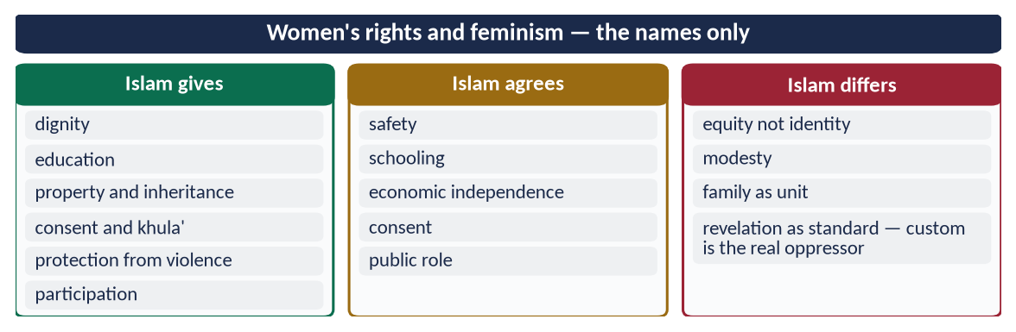
Figure 22 · At a glance — women's rights and feminism — the names only. The detail is in the sections above.

(7) Conclusion
✦ SCHOLARLY VIEW
Quaid-e-Azam Muhammad Ali Jinnah · Speech at Aligarh, 1944
No nation can rise to the height of glory unless its women are side by side with its men.
➜ The founder's vision for Pakistan.

Islam met most of the just demands of the feminist movement long before the movement began, and grounded them in faith rather than struggle. It differs where feminism would separate woman from family and modesty. Pakistan's task is to give women the rights Islam already gave — and that alone would answer the movement.

Why this answer scores
- It describes the rights fully and places them in the context of feminism — agreement and difference.
- It separates Islam from custom and cites Pakistani law.
- Balanced tone — no rejection of just demands, no acceptance of anti-family slogans.

Answer 11 · The Stability of Modern Society Depends on a Strong Family System (CSS 2015)
THE QUESTION · CSS 2015 · Q8 · 16 marks
Stability of modern society depends upon a strong family system in the light of Islamic principles. Discuss.

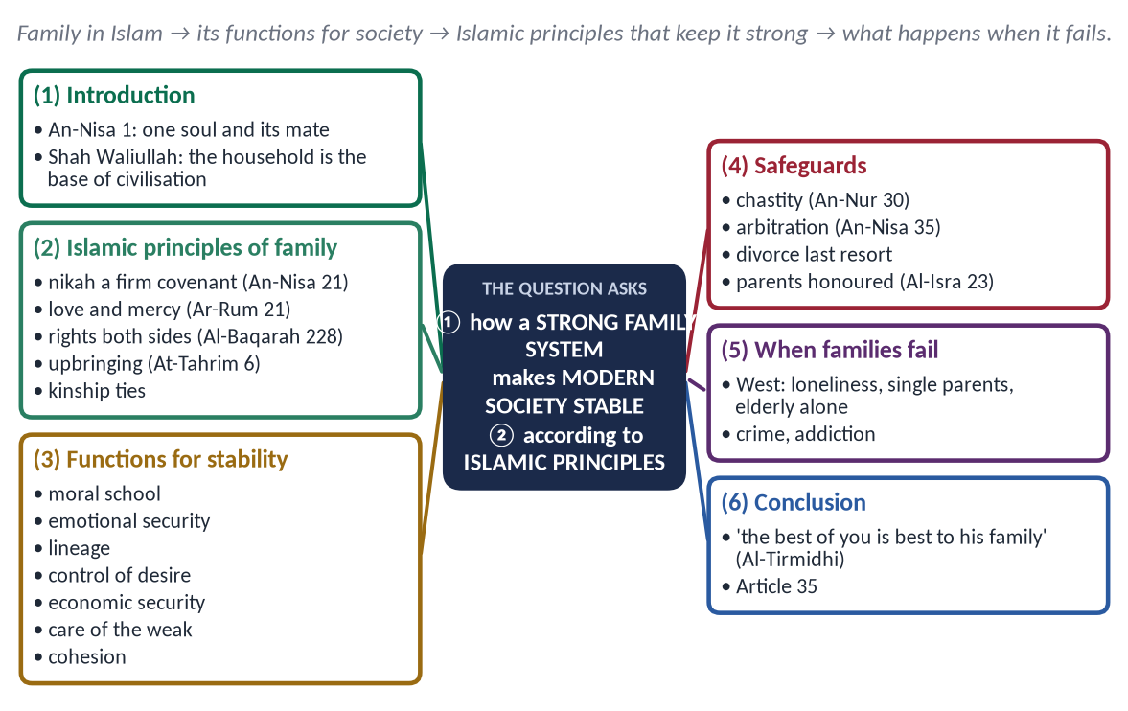
Figure 23 · The answer map: every branch is one numbered heading of the model answer below.

Decoding the question
- 'Stability of modern society depends upon a strong family' — show the link: which family functions keep society stable.
- 'In the light of Islamic principles' — the Islamic structure and safeguards of the family.
- 16 marks — a slightly shorter answer.

The model answer

(1) Introduction
✦ QURAN
﴿يَـٰٓأَيُّهَا ٱلنَّاسُ ٱتَّقُواْ رَبَّكُمُ ٱلَّذِي خَلَقَكُم مِّن نَّفۡسٖ وَٰحِدَةٖ وَخَلَقَ مِنۡهَا زَوۡجَهَا وَبَثَّ مِنۡهُمَا رِجَالٗا كَثِيرٗا وَنِسَآءٗۚ …﴾
“O mankind, fear your Lord, who created you from one soul, created from it its mate, and spread from both of them many men and women.” (An-Nisa, Quran)
➜ All people come from one soul and its mate — the family is the first human institution.

✦ SCHOLARLY VIEW
Shah Waliullah Dehlawi · Hujjat Allah al-Baligha
Shah Waliullah described the household (tadbir al-manzil) as the second stage of civilisation, from which the neighbourhood, the city and the state grow; if the household is corrupt, all that is built on it is corrupted.
➜ The family is the base of civilisation.

Modern society has schools, police, courts and welfare agencies, yet none can replace the family. When the family is strong, society is stable; when it breaks, no institution can repair the damage.

(2) The Islamic principles of the family
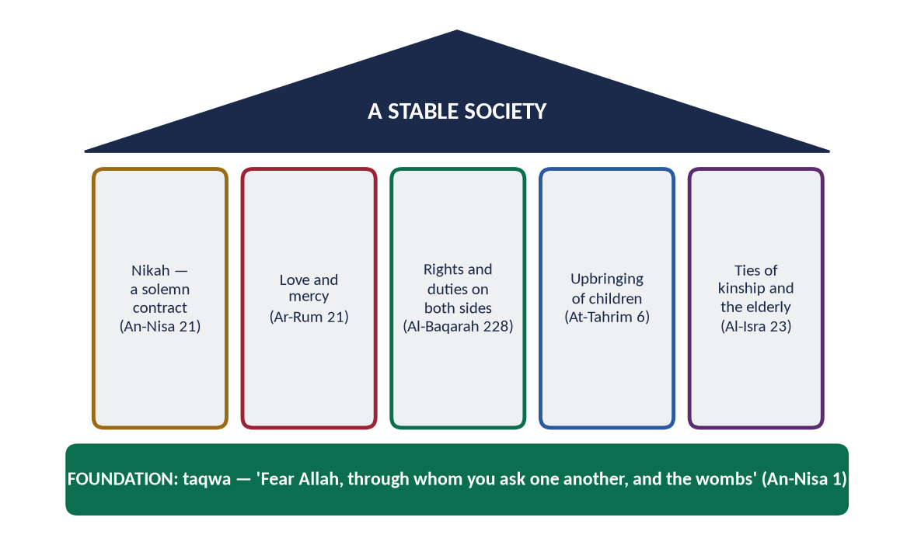
Figure 24 · The Islamic family: foundation, pillars and roof.
- (a) Nikah — a firm covenant: 'they have taken from you a firm covenant' (An-Nisa 21) — consent, witnesses, mahr.
- (b) Love and mercy:
✦ QURAN
﴿وَمِنۡ ءَايَٰتِهِۦٓ أَنۡ خَلَقَ لَكُم مِّنۡ أَنفُسِكُمۡ أَزۡوَٰجٗا لِّتَسۡكُنُوٓاْ إِلَيۡهَا وَجَعَلَ بَيۡنَكُم مَّوَدَّةٗ وَرَحۡمَةًۚ إِنَّ فِي ذَٰلِكَ لَأٓيَٰتٖ لِّقَوۡمٖ يَتَفَكَّرُونَ﴾
“And of His signs is that He created for you from yourselves mates that you may find tranquillity in them; and He placed between you affection and mercy. Indeed in that are signs for a people who give thought.” (Ar-Rum, Quran)
➜ He placed between you love and mercy — the family's emotional core.

- (c) Rights and duties on both sides: 'women have rights like their obligations' (Al-Baqarah 228).
- (d) Upbringing of children:
✦ QURAN
﴿يَـٰٓأَيُّهَا ٱلَّذِينَ ءَامَنُواْ قُوٓاْ أَنفُسَكُمۡ وَأَهۡلِيكُمۡ نَارٗا وَقُودُهَا ٱلنَّاسُ وَٱلۡحِجَارَةُ عَلَيۡهَا مَلَـٰٓئِكَةٌ غِلَاظٞ شِدَادٞ لَّا يَعۡصُونَ ٱللَّهَ مَآ أَمَرَهُمۡ وَيَفۡعَلُونَ مَا يُؤۡمَرُونَ﴾
“O you who have believed, protect yourselves and your families from a Fire whose fuel is people and stones, over which are [appointed] angels, harsh and severe; they do not disobey Allah in what He commands them but do what they are commanded.” (At-Tahrim, Quran)
➜ 'Protect yourselves and your families from a Fire.'

- (e) Honour of parents and kinship ties: not even 'uff' (Al-Isra 23); 'whoever wants his provision increased, let him keep ties with relatives' (Al-Bukhari and Muslim).

(3) How a strong family keeps society stable
Function | Contribution to social stability
Moral school | Honesty, respect and faith learned at home produce law-abiding citizens
Emotional security | Love and mercy prevent loneliness, depression and addiction
Lineage and identity | Clear parentage; rights of names and inheritance
Lawful channel of desire | Marriage reduces adultery, disease and sexual crime
Economic security | Husband maintains wife and children; children maintain parents
Care of the weak | Children, the elderly and the disabled cared for without the state
Social cohesion | Kinship ties link families into communities

(4) Islamic safeguards that keep the family strong
- Chastity and modesty (An-Nur 30–31) protect the marriage.
- Arbitration before divorce:
✦ QURAN
﴿وَإِنۡ خِفۡتُمۡ شِقَاقَ بَيۡنِهِمَا فَٱبۡعَثُواْ حَكَمٗا مِّنۡ أَهۡلِهِۦ وَحَكَمٗا مِّنۡ أَهۡلِهَآ إِن يُرِيدَآ إِصۡلَٰحٗا يُوَفِّقِ ٱللَّهُ بَيۡنَهُمَآۗ إِنَّ ٱللَّهَ كَانَ عَلِيمًا خَبِيرٗا﴾
“And if you fear dissension between the two, send an arbitrator from his people and an arbitrator from her people. If they both desire reconciliation, Allah will cause it between them. Indeed, Allah is ever Knowing and Acquainted [with all things].” (An-Nisa, Quran)
➜ Appoint an arbiter from his family and an arbiter from her family; if they want reconciliation, Allah will bring it about.

- Divorce as a last resort, in stages, with a waiting period for reconsideration.
- Kindness at home:
✦ HADITH
خَيْرُكُمْ خَيْرُكُمْ لِأَهْلِهِ، وَأَنَا خَيْرُكُمْ لِأَهْلِي
“The best of you is the best to his family, and I am the best of you to my family.” (Al-Tirmidhi)

(5) What happens when the family fails — the modern evidence
In many industrial societies, the decline of marriage and the rise of single-parent homes have been linked with child poverty, school dropout, loneliness among the elderly, and addiction. Governments now spend heavily on problems the family once prevented. In Pakistan, rising divorce, neglect of parents and drug use among the young show the same danger.
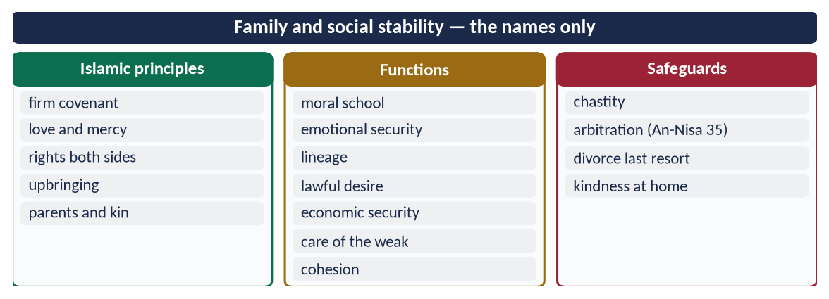
Figure 25 · At a glance — family and social stability — the names only. The detail is in the sections above.

(6) Conclusion
Pakistan's Constitution commits the state to protect marriage, the family, the mother and the child (Article 35). Islam's principles — a solemn covenant, love and mercy, balanced rights, moral upbringing and care of parents — make the family strong, and a strong family is the first guarantee of a stable, moral and peaceful society.

Why this answer scores
- It proves the link between family and social stability, function by function.
- Islamic principles and safeguards are Quran-based; Shah Waliullah gives depth.
- Proportionate length for 16 marks.

Answer 12 · The Challenges for the Institution of Family in the Present Era (CSS 2026)
THE QUESTION · CSS 2026 · Q8 · 20 marks
What are the challenges for the 'institution of family and its role' in the present era? Discuss them in the light of Islamic teachings.

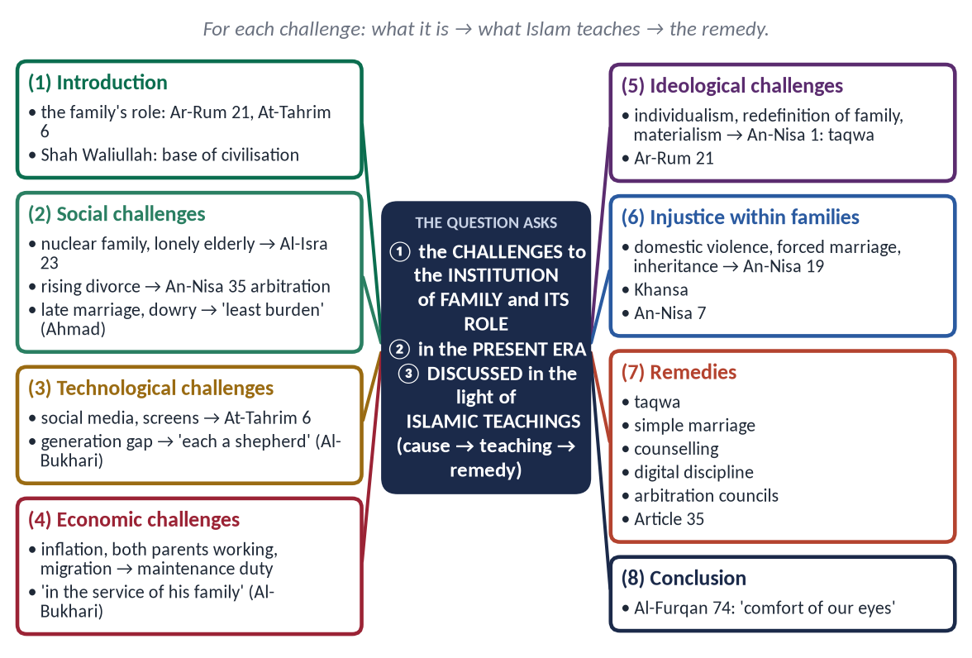
Figure 26 · The answer map: every branch is one numbered heading of the model answer below.

Decoding the question
- 'Challenges' = list and explain the present-day threats — grouped (social, technological, economic, ideological, internal).
- 'Institution of family and its role' = show how each challenge weakens the family's role (moral school, security, care).
- 'In the light of Islamic teachings' = for each challenge, the Islamic teaching and remedy.

The model answer

(1) Introduction — the role of the family
✦ QURAN
﴿وَمِنۡ ءَايَٰتِهِۦٓ أَنۡ خَلَقَ لَكُم مِّنۡ أَنفُسِكُمۡ أَزۡوَٰجٗا لِّتَسۡكُنُوٓاْ إِلَيۡهَا وَجَعَلَ بَيۡنَكُم مَّوَدَّةٗ وَرَحۡمَةًۚ إِنَّ فِي ذَٰلِكَ لَأٓيَٰتٖ لِّقَوۡمٖ يَتَفَكَّرُونَ﴾
“And of His signs is that He created for you from yourselves mates that you may find tranquillity in them; and He placed between you affection and mercy. Indeed in that are signs for a people who give thought.” (Ar-Rum, Quran)
➜ Spouses were created that you may find tranquillity; He placed between you love and mercy.

✦ QURAN
﴿يَـٰٓأَيُّهَا ٱلَّذِينَ ءَامَنُواْ قُوٓاْ أَنفُسَكُمۡ وَأَهۡلِيكُمۡ نَارٗا وَقُودُهَا ٱلنَّاسُ وَٱلۡحِجَارَةُ عَلَيۡهَا مَلَـٰٓئِكَةٌ غِلَاظٞ شِدَادٞ لَّا يَعۡصُونَ ٱللَّهَ مَآ أَمَرَهُمۡ وَيَفۡعَلُونَ مَا يُؤۡمَرُونَ﴾
“O you who have believed, protect yourselves and your families from a Fire whose fuel is people and stones, over which are [appointed] angels, harsh and severe; they do not disobey Allah in what He commands them but do what they are commanded.” (At-Tahrim, Quran)
➜ 'Protect yourselves and your families from a Fire' — the family is the first school of faith and character.

The family's role is to give love, security, moral training and care to every generation. In the present era, this role faces challenges that did not exist a generation ago.

(2) Social challenges

(i) From joint to nuclear family
Urbanisation and migration have broken the joint family; the elderly are left alone and old-age homes are growing in big cities.
✦ QURAN
﴿وَقَضَىٰ رَبُّكَ أَلَّا تَعۡبُدُوٓاْ إِلَّآ إِيَّاهُ وَبِٱلۡوَٰلِدَيۡنِ إِحۡسَٰنًاۚ إِمَّا يَبۡلُغَنَّ عِندَكَ ٱلۡكِبَرَ أَحَدُهُمَآ أَوۡ كِلَاهُمَا فَلَا تَقُل لَّهُمَآ أُفّٖ وَلَا تَنۡهَرۡهُمَا وَقُل لَّهُمَا قَوۡلٗا كَرِيمٗا﴾
“Your Lord has decreed that you worship none but Him, and that you be good to parents. If one or both of them reach old age with you, do not say to them even 'uff', nor repel them, but speak to them a noble word.” (Al-Isra, Quran)
➜ Do not say even 'uff' to parents in old age — their care is the family's duty.

(ii) Rising divorce and khula'
Family courts in Pakistan's cities hear many thousands of cases every year; children suffer most.
✦ QURAN
﴿وَإِنۡ خِفۡتُمۡ شِقَاقَ بَيۡنِهِمَا فَٱبۡعَثُواْ حَكَمٗا مِّنۡ أَهۡلِهِۦ وَحَكَمٗا مِّنۡ أَهۡلِهَآ إِن يُرِيدَآ إِصۡلَٰحٗا يُوَفِّقِ ٱللَّهُ بَيۡنَهُمَآۗ إِنَّ ٱللَّهَ كَانَ عَلِيمًا خَبِيرٗا﴾
“And if you fear dissension between the two, send an arbitrator from his people and an arbitrator from her people. If they both desire reconciliation, Allah will cause it between them. Indeed, Allah is ever Knowing and Acquainted [with all things].” (An-Nisa, Quran)
➜ Arbiters from both families — reconciliation before separation.

(iii) Late marriage and dowry
Expensive weddings and jahez delay marriage and burden parents.
✦ HADITH
إِنَّ أَعْظَمَ النِّكَاحِ بَرَكَةً أَيْسَرُهُ مَؤُونَةً
“The most blessed marriage is the one with the least burden.” (Musnad Ahmad)
➜ Simple marriage is Sunnah.

(3) Technological challenges

(i) Social media and screens
Less time together, comparison and jealousy, exposure of children to harmful content, online harassment.

(ii) The generation gap
Parents and children living in different worlds of language and values.
✦ HADITH
كُلُّكُمْ رَاعٍ وَكُلُّكُمْ مَسْئُولٌ عَنْ رَعِيَّتِهِ
“Each of you is a shepherd, and each is responsible for his flock.” (Al-Bukhari and Muslim)
➜ Parents must guide, not abandon, their children in the digital world.

(4) Economic challenges

(i) Inflation and unemployment
Money stress causes quarrels and long working hours for both parents.

(ii) Migration
Fathers working abroad for years; children raised by one parent.
The Sunnah balances earning with presence: the Prophet ﷺ 'used to be in the service of his family' (Al-Bukhari); the husband's duty of maintenance (At-Talaq 6) is matched by his duty of time and care.

(5) Ideological challenges

(i) Individualism
Marriage seen as a contract of convenience rather than a firm covenant (An-Nisa 21).

(ii) Redefinition of family and gender roles in global media
Islam holds the family to be the union of a man and a woman in nikah, with complementary roles (An-Nisa 1, 34).

(iii) Materialism
Success measured by money, not character — parents with no time for children's moral upbringing.
✦ QURAN
﴿يَـٰٓأَيُّهَا ٱلنَّاسُ ٱتَّقُواْ رَبَّكُمُ ٱلَّذِي خَلَقَكُم مِّن نَّفۡسٖ وَٰحِدَةٖ وَخَلَقَ مِنۡهَا زَوۡجَهَا وَبَثَّ مِنۡهُمَا رِجَالٗا كَثِيرٗا وَنِسَآءٗۚ …﴾
“O mankind, fear your Lord, who created you from one soul, created from it its mate, and spread from both of them many men and women.” (An-Nisa, Quran)
➜ 'Fear Allah, through whom you ask one another, and the wombs' — taqwa and kinship are the family's foundation.

(6) Injustice within families
Domestic violence, forced marriage, denial of inheritance and neglect of parents weaken the family from within.
✦ QURAN
﴿… وَعَاشِرُوهُنَّ بِٱلۡمَعۡرُوفِۚ …﴾
“And live with them in kindness.” (An-Nisa, Quran)
➜ 'Live with them in kindness.'

Forced marriage is void in spirit — Khansa's marriage was annulled (Al-Bukhari); daughters have an obligatory share (An-Nisa 7).
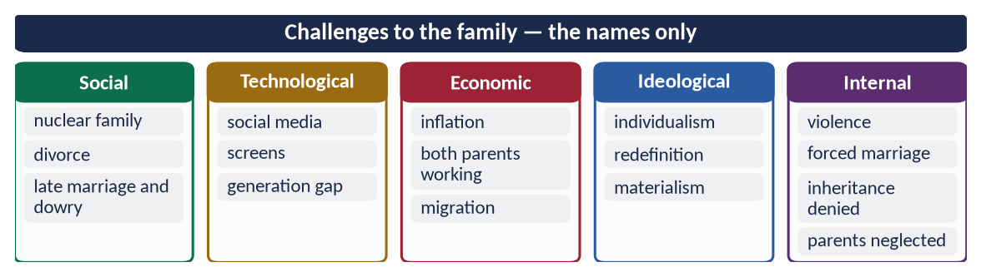
Figure 27 · At a glance — challenges to the family — the names only. The detail is in the sections above.

(7) The Islamic remedies
- (a) Taqwa at the base (An-Nisa 1).
- (b) Simple marriage — end dowry culture ('the least burden').
- (c) Pre-marriage counselling on rights and duties; the nikah nama explained.
- (d) Time and presence — family meals and prayers together; the father as a model.
- (e) Digital discipline — screen rules; parental guidance.
- (f) Arbitration before divorce — strengthen the Arbitration Councils of the Muslim Family Laws Ordinance 1961.
- (g) Care of the elderly at home (Al-Isra 23).
- (h) The state's duty — Article 35: protect marriage, family, mother and child; family-friendly work, housing and schools.
Figure 28 · The Islamic family: the structure that answers these challenges.

(8) Conclusion
✦ QURAN
﴿وَٱلَّذِينَ يَقُولُونَ رَبَّنَا هَبۡ لَنَا مِنۡ أَزۡوَٰجِنَا وَذُرِّيَّـٰتِنَا قُرَّةَ أَعۡيُنٖ وَٱجۡعَلۡنَا لِلۡمُتَّقِينَ إِمَامًا﴾
“And those who say, "Our Lord, grant us from among our wives and offspring comfort to our eyes and make us an example for the righteous.” (Al-Furqan, Quran)
➜ 'Our Lord, grant us from our spouses and children the comfort of our eyes.'

The family today faces social, technological, economic and ideological pressures, and injustice from within. Islam's teachings answer each: taqwa, love and mercy, simple marriage, balanced rights, moral upbringing, arbitration and care of parents. A society that protects its families protects its future.

Why this answer scores
- Challenges are grouped and each is matched with an Islamic teaching and remedy — exactly 'in the light of Islamic teachings'.
- It speaks of the family's role, as the question's own words require.
- Pakistani references (MFLO 1961, Article 35) make it contemporary.

